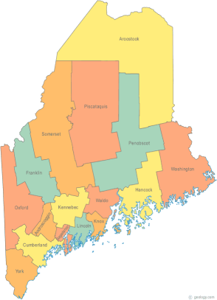 | Meeting of the Maine Continuum of Care  June 20, 2019 1:00 pm to 3:00 pm  Meeting at FOUR locations via GoTo Meeting  - MaineHousing, 353 Water St, Augusta  - New Beginnings, 134 College Street, Lewiston  - Shalom House, 106 Gilman Street, Portland  - PCHC Admin Building, 103 Maine Ave, Bangor  Please try to attend at one of the group sites listed above. For those unable to attend a designated group site in person, GoTo Meeting information for joining the meeting from your computer, tablet or smartphone is listed below. If you want to setup a group site at your agency let Scott know!  https://global.gotomeeting.com/join/352415877  To join via phone, call: +1 (646) 749-3122 Access Code: 352-415-877  (Please use either your phone or your computer audio to connect – do not use both!)
---Agenda Items---
- Member Introductions |  | All
- Review & Approval of minutes* |  | All | *Need to Vote
- Big Thinking Topic – Resource Committee Quarterly PIT Update |  | All
- MaineHousing’s next 5-year Con Plan Discussion |  | MaineHousing
- Update on the Homeless Solutions Rule Change Progress |  | MaineHousing
- State and Federal Legislation |  | Cullen
- Statewide Homeless Council Update |  | Cullen
- Regional Homeless Council Updates |  | All
- Long Term Stayers Update |  | All
- CoC Board Update  - General updates & any decisions made by the BOD – Standing agenda item  - Strategic Planning Update – Standing agenda item  - Coordinated Entry Update – Standing agenda item |  | All
- NOFA Related updates:  - Updated MCOC Governance*  - Selection Committee Charter  - The Gaps and Needs Analysis update!  - Systems Performance Measures update! |  | Scott | *Need to Vote
- Brief Standing Committee Updates:  - Brief, pertinent Committee updates as applicable |  | All
- Letter of Support Request – FYSB TLP Grant |  | All | *Need to vote
- HUD TA Community of Practice - Governance |  | Scott
- Next Agenda – Items for next month |  | All
- Any Other Business
Next Meeting: July 18, 2019 1pm to 3pm
Please read all materials prior to attending the meetings in order to be prepared to participate in the discussion.
Materials posted at www.mainehomelessplanning.org Contact stibbitts@mainehousing.org for more information.

