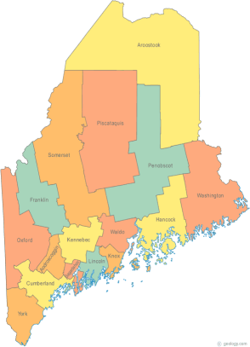 | Meeting of the Maine Continuum of Care  March 21, 2019 1:00 pm to 3:00 pm  Meeting at SIX locations via Tandberg Conferencing System.  Meeting Available at up to Seven locations via Tandberg Conferencing System.  - Turner Memorial Library, 39 2nd St., Presque Isle (call ahead to let them know)  - Farmington Public Library, 117 Academy Street, Farmington (call ahead to let them know)  - MaineHousing, 353 Water St, Augusta  - Lewiston Public Library, 200 Lisbon Street, Lewiston  - Portland Public Library, 5 Monument Square, Portland  - Bangor Public Library, 145 Harlow St. Bangor (not available for March 21st)  THE CALL-IN ONLY NUMBER FOR THIS MEETING IS 866-6426.  If you are at a Tandberg Location, use the system audio, not the call in #.  And please – only use the call in if you cannot make it to a Tandberg site.
---Agenda Items---
- Member Introductions |  | All
- Review & Approval of minutes* |  | All | *Need to Vote
- MCOC Chair Vacancy |  | Chairs
- Big Thinking Topics –  - CoC Committees Presentation – Information and Committee Charters  - Data Sharing Work Group Document Review* |  | All | *Need to Vote
- FY 18 NOFA Competition Debrief |  | NOFA Committee
- PIT, HIC, and System Performance Measures – Discussion & Submission Deadlines |  | All
- State and Federal Legislation |  | Cullen
- Statewide Homeless Council Update |  | Cullen
- Regional Homeless Council Updates |  | All
- Long Term Stayers Update |  | All
- CoC Board Update  - MCoC NAEH Conference Scholarship Opportunity*  - Strategic Planning Update – Standing agenda item  - Coordinated Entry Update – Standing agenda item |  | All | *Need to Vote
- Brief Standing Committee Updates:  - Brief, pertinent Committee updates as applicable  - Youth Committee – Youth Homelessness Demonstration Program NOFA announcement, process, and application* |  | All | *Need to Vote
- Any Other Business |  | All
Next Meeting: April 18, 2019 1pm to 3pm
Please read all materials prior to attending the meetings in order to be prepared to participate in the discussion.
Materials posted at www.mainehomelessplanning.org Contact stibbitts@mainehousing.org for more information.

