Coordinated Entry Implementation Committee
January 30, 2017
10:00-1:00
Preble Street Main Office Conference Room
38 Preble Street
Summary
Attendees: James Gagne, Stacy Spalding, Adam Harr, Vickey Rand, Rob Parritt, Steve Ellis, Rachel Boyce, Amy Grommes Pulaski
Phone: Julia and Amanda (MaineHousing HMIS), Derek (211), Cindy Namer (MaineHousing),Ginny Dill, Wendy Thomas (HUD VASH), Jenny (Family Crisis)
- Review and approve minutes from previous meeting (5 minutes)
The goal is to post approved minutes on MaineHomeless Planning website, as requested by the BOD and others. Rob moves to accept the minutes, Stacy seconded, all in favor.
- Slideshow/CAARES Map, James (Vickey or Rob will need to take the CAARES Map) (20 minutes)
This group was tasked with improving with the existing Coordinated Entry system. This group is relatively new to CE, however the COC BOD has worked on Coordinated Entry for years. It began with Cloudburst in the creation of the CAARES map. Reviewing the CAARES map will give us a frame of reference, and understanding of the BOD’s intent. How do we want people to access and move through the system. In the last meeting it was brought up that we should not “cause more harm” in serving individuals and this was a mentality that was intended by the BOD. This is a client-focused process.
Vickey walks through the original CAARES Map. She explains that CE as we have been working on it has only been Access, Diversion and Prescreen. Some items of CE has changed from the original CAARES Map.
There have been many updates to Coordinated Entry from HUD, since this first iteration. There are a number of best practice models of which one is Coordinated Entry entities, where there is one or two point person that take application, waitlist, appeals process, etc. Instead of having every Navigator or PATH provider doing this, you could have just one or two people do all this work. Sometimes this is 2-1-1, other times its departments within other organizations.
The group decides to role play.
Add to scripting:
- DV scripting
- Change “If No, Please jump to Section B”
- Preferred community for shelter options: Review Mediware options.
After the Prescreen, diversion and triage, they group walks through the shelter intake.
Once someone is referred to a shelter, that shelter does their intake which includes UDE’s and access to a shelter bed. Policies and Procedures should include UDE, for more specific see appendix, or website. Suggestion, create own P&P and don’t reference other programs requirements in case they change or go away. However, we can include ESG Written Standards, because they are required to participate in CE by HUD.
Assessment:
The group reviewed the CE Flow Chart that James created and presented last week and make updates to it.
Step 2 Intake: UDE’s, shelter specific intake questions;
Step 3 Assessment and Prioritization: VI-SPDAT, Maine Prioritization Plan (Length of Stay (not defined))
- If VI-SPDAT 0 to 3: no housing Stability Plan goto Step 5: Self Resolve.
- If VI-SPDAT 4: goto Step (4 new) HSP
Step 4 (new) Housing Stability Plan: Complete a Housing Stability Plan. Goto Step 5b
Step 5 (previously step 4): Housing Intervention and Referral:
- Self-resolve
- Permanent Housing, Transitional Housing, Rapid Rehousing, Permanent Supportive Housing
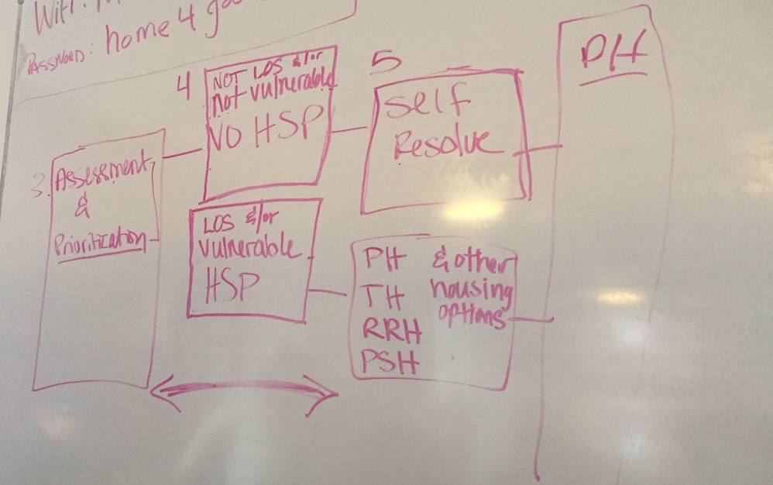
Look at wording from Policies and Procedures North West Minnesota.
They do not wish to define Length of Stay (LOS).
Use the term “Housing Stability” instead of “Housing Barrier”
Prioritization: Reviewing all the information you know about the client (VI-SPDAT score, Housing Barrier/ stability, vulnerability) and prioritizing them.
At this time, the group decides the less specific, the better. Many requirements exist in other programs, and there is fear that it could contradict. Keep the options as flexible at this point. There is standardization, written standards, and policies and procedures that define. You can reference other requirements without setting limits at this point.
This currently works and works well. Let’s allow it to succeed.
- Review Shelter GEO Codes, as available (15 minutes)
Mainehousing HMIS staff has requested this information form all shelters. This information has been submitted and shared with Mediware. There are several options. The committee is interested in clients choosing more than one location however this isn’t an option currently.
Here’s some options
- Choose one county
- Add, No preference
- Add, All counties
- Choose specific regions.
Ask Mediware if we can have on the pick list: 16 counties, plus no preference, all counties, and “Southern Maine” which includes York, Cumberland etc. or Region 1, 2, 3
Julia- to send list of GEO Codes from Shelters.
- Create HMIS Scripting (30 minutes)
  - Note the request that all clients pass through diversion before being connect with shelter.
Review scripting that’s been created. Some of this will come from the framework that we outlined.
NOTE to MEDIWARE:
Under Was where you stayed last night a safe location that you can return to?
REMOVE : If yes, continue to answering diversion questions. If no, jump to section B.
Add back in scripting before shelter eligibility questions.
Script: I need to understand a little more about you before referring you to a specific shelter, please answer the following questions as honestly as possible.
- Discuss with COC BOD (20 minutes)
  - Discuss information to present to the COC BOD
- Updated Version in HMIS, James
- Present updated version of James CE Flow Chart, James
- Live walk through with example client, Scripting discussion. James and volunteer.
- Next steps:
  - Policies and Procedures
- Request from BOD: Vote: For the Committee to continue to work on implementation.

- Next steps:
  - CE Policies and Procures, Leah/Cindy
  - Articulate need for technical Assistance to request approval from COC BOD.
  - Create standing meeting
  - Create means to provide feedback and communication with MH and Mediware

