Coordinated Entry Implementation Committee
January 23, 2017
10:00-1:00
Location TBD

AGENDA
Attendees: James Gagne, Stacy Spalding, Vickey Rand, Adam Harr, Steve Ellis, Rob Parrit, Rachel Boyce, Ginny Dill, Julia Kimbal HMIS, Derek, Betty Palmer, David Soveteky, Lucas (YCSP), Bill Higgins, Amy Grommes Pulaski
- Review list of PATH, SSVF Providers, as available
The committee reviews the list as presented. They notice that there are specific persons listed as contacts.
Committee recommends forwarding list of PATH and SSVF resources and counties served, removing admin, to Mediware to input into the software.

Questions: Policies and Procedures – who updates contacts for PATH and SSVF Providers. There was a suggestion to create a form for personnel changes.
- Review Shelter GEO Codes, as available
No information provided yet. Need to know which counties.
Julia informed the committee that an email has been sent with the following questions: What counties do you serve? And What counties do you accept referrals from? As of the meeting, 10 responded. The survey is due on Jan 23 by noon.

For shelters, in order to build the software, if the shelter has not replied, the committee recommends defaulting to statewide until they indicate otherwise.
Continue to outreach to shelters to have the updated information prior to going live. It is hoped that the report will be complete by the next CE meeting.
- Review feedback from Mediware and screen shots provided.
The group reviews who will be entered into HMIS. Question 2 addresses client permission on data sharing. There was some confusion whether the question asked for permission to share or collect and share. The language asks if a client would allow their data to be BOTH COLLECTED AND SHARED. If they say no, the instructions are to not enter them into HMIS. It’s a combined, collection and sharing question.
HUD specifies that all people must be treated equally regardless of whether they choose to allow their data to be collected and shared.
Derek explained he can collect the information in VISION LINK, a 2-1-1 software, listing the number of people who refuse to share data. Listed as Coordinated Entry person, but did not want to share. They would still go through coordinated entry and receive the 2-1-1 referrals, which would be shelters. It does not deny them any access to services.
The committee reviews the screen shots provided by Mediware. They are pleased with the updated screen shots in HMIS. They have a few recommendations for changes:
- Add “legally” to question 4: If under 18 are you [LEGALLY] emancipated?
- Add back in Question 7: Caller City.
- Move question 9 to be question 10, under Diversion. Was where you stayed last night a safe location that you can return to?
Note: The group decided that ALL clients that call 2-1-1 will go through diversion assessment questions.
- Add question 15: “Was client successfully diverted?” Yes or No. (Scripting: If yes, End assessment and proceed to referrals. If no, Continue with assessment. )
- Do you have open or outstanding warrants for arrest?
Add pick list: Yes, No, Client doesn’t know, Client refused.
Add: “If yes, please explain to the referral agency“ (Mediware -> do not add text box, 2-1-1 in warm hand off.
- Are you required to register as a sex offender in the State of Maine? Add: “If yes, please explain to the referral agency “(do not add text box, 2-1-1 in warm hand off.
Add pick list: Yes, No, Client doesn’t know, Client refused.
Add: “If yes, please explain to the referral agency“ (Mediware -> do not add text box, 2-1-1 in warm hand off.
Do you currently have a felony conviction? (criteria: length of time? Etc.) Just have this questions as Y/N
Add pick list: Yes, No, Client doesn’t know, Client refused.
Add: “If yes, please explain to the referral agency“ (Mediware -> do not add text box, 2-1-1 in warm hand off.
- Uniform Coordinated Assessment and CE Policies and Procures,
The committee reviews the original Uniform Coordinated Assessment form and reviews the question. The first three sections are the sections that they have been reviewing in Service Point. They get to the Section 4 Program/ Data Entry.
Need to get an updated list of UDE questions (ask Leah and Cindy).
Polices and procedures would reference the questions will be based on the most updated program entry forms (ESHAP, PATH, SSVF) and UDE’s.
  - Review draft, edit and update
The group reviewed the policies and procedures. The sections addressing policy appear to be well defined. There decide to focus first on the sections addressing how CE will work, and its process, including CES Process and Initial Engagement.
They discussion the prioritization. Parts of the prioritization appear to be very prescriptive. They question where this came from. Are they from the ESHAP applications, and/or ESG Written Policies. They decide to ask MaineHousing staff. is prescriptive. Where did they come from?
Ask MaineHousing staff where the VISPDAT scores for prioritization originated.
There are several versions of the SPDAT, this VI SPDAT is for very initial encounters and for street outreach. The committee discusses this as a tool to use for Coordinated Entry. How do we incorporate the Maine Prioritization Assessment Tool, when shelters are currently using the VISPDAT?
Another question, and discussion: How is diversion happening at shelters? We need a standard process so that there is equal access from 2-1-1 or whether they show up at a shelter.
  - James created a MCOC CE Flow Chart
The group likes the flow chart that James created. They discuss combining Intake and Assessment and Prioritization, but after discussion, decide to keep them separate.
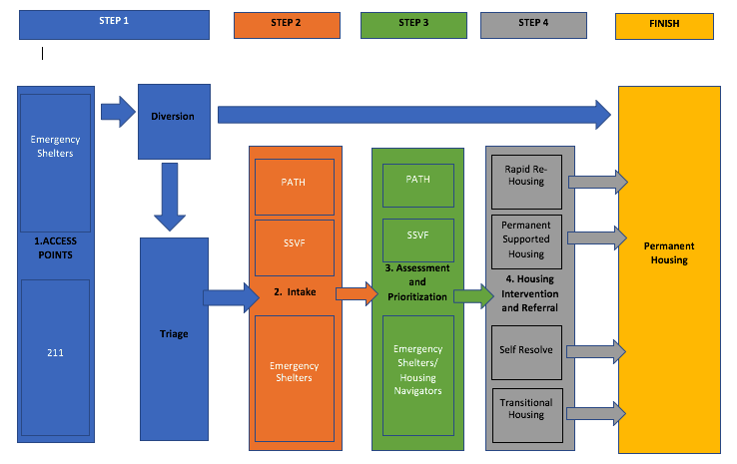
Flow steps to add:
- How do Veterans go from 2. Intake to the Veterans system??
- How do Youth play into this system??
This conversation needs to continue with more people around the table, including MaineHousing, plus Shelter and Housing providers.
Have CE Requirements as a reference.
  - Review ESG Written Standards, identify which standards align with CE and add to CE Policies and Procedures
- Schedule next meeting and Create CE standing meeting, and means to provide feedback and communication with MaineHousing and Mediware
Documents for next meeting
- ESG Written Standards
- Policies and Procedures
- James Chart
- ESHAP application requirements for shelters (HCV and STEP requirements)
- Uniform Assessment

- Next Steps:
- Create HMIS Scripting
- Request that all clients pass through diversion before being connect with shelter.
- Articulate need for technical Assistance to request approval from COC BOD.

