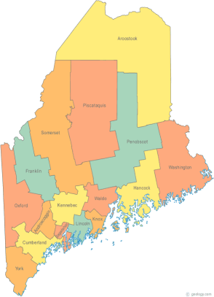 | Meeting of the Maine Continuum of Care  February 15, 2018 1:00 pm to 3:00 pm  Meeting at SIX locations via Tandberg Conferencing System.  - Turner Memorial Library, 39 2nd St., Presque Isle (call ahead to let them know)  - Farmington Public Library, 117 Academy Street, Farmington (call ahead)  - MaineHousing, 353 Water St, Augusta  - Lewiston Public Library, 200 Lisbon Street, Lewiston  - Portland Public Library, 5 Monument Square, Portland  - Bangor Public Library, 145 Harlow St. Bangor – Unavailable in February and March  THE CALL-IN ONLY NUMBER FOR THIS MEETING IS 866-6433.  If you are at a Tandberg Location, use the system audio, not the call in #.  And please – only use the call in if you cannot make it to a Tandberg site.
---Agenda Items---
- Member Introductions |  | All
- Review & Approval of minutes |  | All | Need to Vote
- Big Thinking Topic – Coordinated Entry Update and Discussion |  | All
- State and Federal Legislation |  | Cullen
- Statewide Homeless Council |  | Cullen
- Regional Homeless Council Updates |  | All
- Long Term Stayers Update |  | All
- CoC Board Update  - Strategic Planning Update – Standing agenda item  - Coordinated Entry Update – Standing agenda item |  | All
- Brief Standing Committee Updates:  - Data  - Project/Monitoring – Discussion regarding monitoring forms, process, etc.  - Policy  - Resource – PIT update  - Special Populations:  - Veterans – VOANNE GPD Program Letter of Endorsement  - Youth – Homeless Youth Demonstration Grant discussion and update |  | All | Need to vote
- Any Other Business |  | All
Next Meeting: March 15, 2018, 1pm to 3pm
Please read all materials prior to attending the meetings in order to be prepared to participate in the discussion.
Materials posted at www.mainehomelessplanning.org Contact stibbitts@mainehousing.org for more information.

