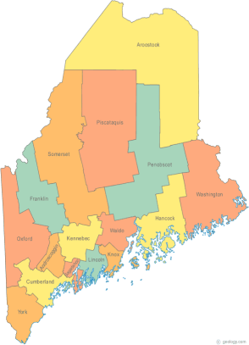 | Meeting of the Merged Maine Continuum of Care  August 17, 2017 1:00 pm to 3:00 pm  Meeting at SIX locations via Tandberg Conferencing System.  - Turner Memorial Library, 39 2nd St., Presque Isle (call ahead to let them know)  - Farmington Public Library, 117 Academy Street, Farmington (call ahead)  - MaineHousing, 353 Water Street, Augusta  - Lewiston Public Library, 200 Lisbon Street, Lewiston  - Portland Public Library, 5 Monument Square, Portland  - Bangor Public Library, 145 Harlow St. Bangor  THE CALL-IN ONLY NUMBER FOR THIS MEETING IS 866-6433.  If you are at a Tandberg Location, use the system audio, not the call in #. And please – only use the call in if you cannot make it to a Tandberg site.
---Agenda Items---
- Member Introductions |  | All
- Review & Approval of minutes |  | All | Need to Vote
- Big Thinking Topic – CoC NOFA  - Due dates / timeline  - NOFA meetings  - Scoring tools – renewal and new projects |  | All
- MCOC Governance |  | All | Possible Vote
- Preble Street Project Applicant Request |  | All | Possible Vote
- State and Federal Legislation |  | Cullen
- Statewide Homeless Council |  | Cullen
- Regional Homeless Council Updates |  | All
- Long Term Stayers Update |  | All
- CoC Board Update  - Consolidation Committee Update – Standing agenda item  - Coordinated Entry Update – Standing agenda item |  | All
- HMIS Governance Ad Hoc Committee Update |  | All | Possible Vote
- Committees, Committee Membership, and Reminder of Election of Committee Chairs |  | All
- Any Other Business |  | All
Next Meeting: September 21, 2017, 1pm to 3pm

Please read all posted materials prior to attending the meetings in order to be prepared to participate in the discussion.
Materials will be posted at www.mainehomelessplanning.org
Contact stibbitts@mainehousing.org for more information.

