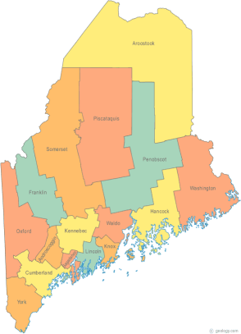 | Maine Continuum of Care (MCOC) Agenda  April 20, 2017 1:00 pm to 3:00 pm  Meeting at SIX locations via Tandberg Conferencing System.  - Turner Memorial Library, 39 2nd St., Presque Isle  - Farmington Public Library, 117 Academy Street, Farmington  - MaineHousing, 353 Water Street, Augusta  - Lewiston Public Library, 200 Lisbon Street, Lewiston  - Portland Public Library, 5 Monument Square, Portland  - Bangor Public Library, 145 Harlow St. Bangor  THE CALL-IN ONLY NUMBER FOR THIS MEETING IS 866-6433.  If you are at a Tandberg Location, use the system audio, not the call in #. And please – only use the call in if you cannot make it to a Tandberg site
---Agenda Items---
- Member Introductions |  | All
- Review & Approval of minutes |  | All | Need to Vote
- Big Thinking Topic – None this month |  | All
- State and Federal Legislation |  | Cullen
- Statewide Homeless Council |  | Cullen
- Regional Homeless Council Updates |  | All
- Long Term Stayers Update |  | All
- CoC Board Update  - Merger Discussion – Standing agenda item  - Coordinated Entry Update – Standing agenda item |  | All | Need to Vote
- HMIS Governance Ad Hoc Committee Update |  | All
- HUD visit – May 12th |  | All
- HIC/PIT – Update |  | All
- Rural Youth Peer Network Initiative – Phase II Update |  | All
- NOFA Prep – Standing agenda item |  | All
- Any Other Business |  | All
Next Meeting: May 18, 2017, 1pm to 3pm

Please read all posted materials prior to attending the meetings in order to be prepared to participate in the discussion.
Materials will be posted at www.mainehomelessplanning.org
Contact stibbitts@mainehousing.org for more information.

