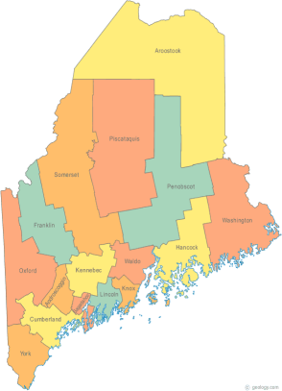 | Maine Continuum of Care (MCOC) Agenda  December 15, 2016 1:00 pm to 3:00 pm  Meeting at SIX locations via Tandberg Conferencing System.  - Turner Memorial Library, 39 2nd St., Presque Isle  - Farmington Public Library, 117 Academy Street, Farmington  - MaineHousing, 353 Water Street, Augusta  - Lewiston Public Library, 200 Lisbon Street, Lewiston  - Portland Public Library, 5 Monument Square, Portland  - Bangor Public Library, 145 Harlow St. Bangor  THE CALL-IN ONLY NUMBER FOR THIS MEETING IS 866-6433.  If you are at a Tandberg Location, use the system audio, not the call in #. And please – only use the call in if you cannot make it to a Tandberg site
---Agenda Items---
- Member Introductions |  | All
- Review & Approval of minutes |  | All | Need to Vote
- Big Thinking Topic – Merger Discussion |  | All
- Steering Committee Update  - Steering Retreat |  | All | Need to Vote
- State and Federal Legislation |  | Cullen
- Statewide Homeless Council |  | Cullen
- Regional Homeless Council Updates |  | All
- Long Term Stayers Update |  | All
- Vets@Home TA Update |  | Phil
- CoC Board Update |  | All
- HMIS Governance Ad Hoc Committee Update |  | All
- PIT Update / Youth PIT Count Update  - PIT Forms – Need to vote |  | Resource Committee | Need to Vote
- Any Other Business  - CHOM 2015 York County CH Project – Request  - Nominations for Tri-Chair Position |  | All | Need to Vote
Next Meetings: January 19, 2017 1pm to 3pm
Please read all posted materials prior to attending the meetings in order to be prepared to participate in the discussion.
Materials will be posted at www.mainehomelessplanning.org
Contact stibbitts@mainehousing.org for more information.

