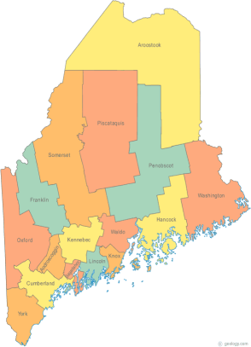 | Maine Continuum of Care (MCOC) Agenda  October 20, 2016 1:00 pm to 3:00 pm  Meeting at SIX locations via Tandberg Conferencing System.  - Turner Memorial Library, 39 2nd St., Presque Isle  - Farmington Public Library, 117 Academy Street, Farmington  - MaineHousing, 353 Water Street, Augusta  - Lewiston Public Library, 200 Lisbon Street, Lewiston  - Portland Public Library, 5 Monument Square, Portland  -AND, BANGOR PUBLIC LIBRARY – 145 Harlow St. Bangor  THE CALL-IN ONLY NUMBER FOR THIS MEETING IS 866-6433.  If you are at a Tandberg Location, use the system audio, not the call in #. And please – only use the call in if you cannot make it to a Tandberg site
---Agenda Items---
- Member Introductions |  | All
- Review & Approval of minutes |  | All | Need to Vote
- Program Component Type Changes |  | Paula
- Big Thinking Topic – CoC NOFA Debrief, including:  - Discussion regarding the Selection Committee’s tasks between NOFAs;  - Monitoring & Scoring different project types (i.e. HMIS) |  | All
- Steering Committee Update |  | All
- State and Federal Legislation |  | Cullen
- Statewide Homeless Council |  | Cullen
- Regional Homeless Council Updates |  | All
- Long Term Stayers Update |  | All
- Vets@Home TA Update |  | Phil
- CoC Board Update |  | All
- HUD Youth Demonstration Grant |  | All
- HMIS Data Quality Plan |  | All
- PIT Unsheltered Count Methodology and Planning |  | Phil and Janice
- Upcoming preliminary discussions re. potential CoC merger |  | All
- Any Other Business |  | All
Next Meetings: November 17th, 1pm to 3pm
Please read all posted materials prior to attending the meetings in order to be prepared to participate in the discussion.
Materials will be posted at www.mainehomelessplanning.org
Contact ppaladino@mainehousing.org for more information.

