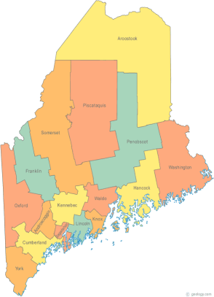 | Maine Continuum of Care (MCOC) Agenda  February 18, 2016 1:00 pm to 3:00 pm  Meeting at TWO locations via Tandberg Conferencing System.  - - MaineHousing, 353 Water Street, Augusta  - Lewiston Public Library, 200 Lisbon Street, Lewiston  - Portland Public Library, 5 Monument Square, Portland – OFFLINE THIS MONTH  THE CALL-IN ONLY NUMBER FOR THIS MEETING IS 866-6433  If you are at a Tandberg Location, use the system audio, not the call in.
---Agenda Items---
- Member Introductions |  | All
- Review & Approval of minutes |  |  | Need to Vote
- Steering Committee Update |  | All
- Resource Committee Update |  | Chairs
- Data Committee Update |  | Chairs
- Project Committee Update |  | Chairs
- Scoring Template Committee Update |  | Chairs
- Governance Ad Hoc Committee Update |  | Chairs
- Policy Committee Update |  | Chairs
- State and Federal Legislation |  | Cullen
- Statewide Homeless Council |  | Wes or Cullen
- Long Term Stayers Update |  | All
- Vets@Home TA Update |  | Phil Allen
- CoC Leadership Group Update |  | All
- Support Letters |  | All
- Annual Shelter Statistics Report |  | MaineHousing
- Big Thinking Topic – Shelters and how they fit into the CoC |  | All
- Any Other Business |  | All
Next Meetings: March 17th, 1pm to 3pm

Please read all posted materials prior to attending the meetings in order to be prepared to participate in the discussion.
Materials will be posted at www.mainehomelessplanning.org
Contact stibbitts@mainehousing.org for more information.

