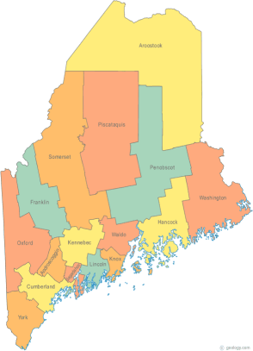 | Maine Continuum of Care (MCOC) Agenda  January 21, 2016 1:00 pm to 3:00 pm  Meeting at SEVEN locations via Tandberg Conferencing System.  - Turner Memorial Library, 39 2nd St., Presque Isle  - Torrey Hall Rm 109 (or possibly 111) UMM Campus, Machias  - UMO Campus 11 Shibles Hall, Orono (NEW – Bangor Replacement)  - Farmington Public Library, 117 Academy Street, Farmington  - MaineHousing, 353 Water Street, Augusta  - Lewiston Public Library, 200 Lisbon Street, Lewiston  - Portland Public Library, 5 Monument Square, Portland  THE CALL-IN ONLY NUMBER FOR THIS MEETING IS 866-6401  If you are at a Tandberg Location, use the system audio, not the call in.
---Agenda Items---
- Member Introductions |  | All
- Review & Approval of minutes |  |  | Need to Vote
- Parkwoods Discussion |  | All
- SOAR TA Opportunity |  | All
- Chronic Homelessness Webinar |  | All
- NOFA Debrief |  | All
- Governance |  | All
- Steering Committee Update |  | All
- Resource Committee Update |  | Chairs
- Data Committee Update |  | Chairs
- Project Committee Update |  | Chairs
- Policy Committee Update |  | Chairs
- State and Federal Legislation |  | Cullen
- Long Term Stayers Update |  | All
- Vets@Home TA Update |  | Phil Allen
- Big Thinking Topic |  | All
- Any Other Business |  | All | Need to Vote
Next Meetings: February 18th, 1pm to 3pm

Please read all posted materials prior to attending the meetings in order to be prepared to participate in the discussion.
Materials will be posted at www.mainehomelessplanning.org
Contact stibbitts@mainehousing.org for more information.

