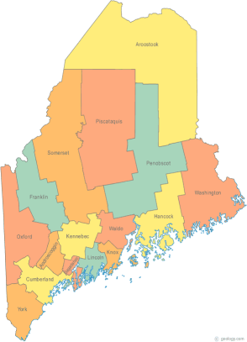 | Maine Homeless Policy Committee  Agenda  Friday, July 10, 2015 3:00PM  Community Housing of Maine  309 Cumberland Ave., Suite 203  Portland, ME 04101  Call-in number 1-605-475-4350  Access Code: 810236#
-Agenda Items-

- Welcome/Introductions/Attendance | Group

- Items of Current Focus  Federal & State Legislation | Group

- Proactive Strategies, Outline of discussion at Delegation meetings in DC next week | Group

- What we are for, and why. (Why certain policies can work). | Group

- Next Meeting (confirm time and location)/Adjournment

