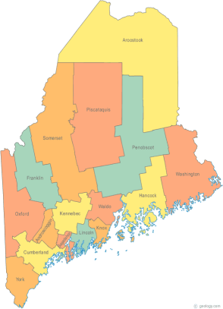 | MCOC Policy Committee  Agenda  Friday, April 10, 2015 3:00PM  Community Housing of Maine  309 Cumberland Ave., Suite 203  Portland, ME 04101  Call-in number 1-605-475-4350  Access Code: 810236# | All Committee Agendas and Minutes will be sent to MCOC Chairs by the 10th of each month for inclusion in materials sent to all members prior to each monthly MCOC meeting.
-Agenda Items-

- Welcome/Introductions/Attendance | Group

- Items of Current Focus | Group

- Proactive Strategies | Group

- What we are for, and why. (Why certain policies can work). | Group

- Federal & State Legislation | Cullen

- Next Meeting (confirm time and location)/Adjournment

