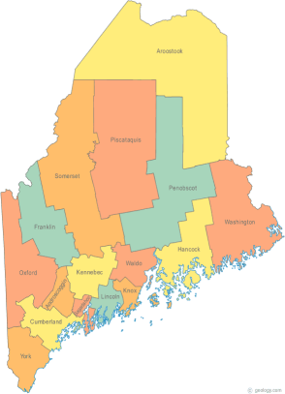 | Maine Continuum of Care (MCOC) Agenda  March 19, 2015 12:00* pm to 3:00 pm  Meeting at SEVEN locations via Tandberg Conferencing System.  - Turner Memorial Library, 39 2nd St., Presque Isle  - Torrey Hall Rm 109 (or possibly 111) UMM Campus, Machias  - UMO Campus 11 Shibles Hall, Orono (NEW – Bangor Replacement)  - Farmington Public Library, 117 Academy Street, Farmington  - MaineHousing, 353 Water Street, Augusta  - Lewiston Public Library, 200 Lisbon Street, Lewiston  - Portland Public Library, 5 Monument Square, Portland
*Note: From noon to 1:00 pm there will be a meeting regarding the VA Homeless Gap Analysis Tool. Tandberg sites at all locations will be connected beginning at noon.

For those not able to attend at a Tandberg location, you may call in to the meeting at 866-6498.
---Agenda Items---
- Member Introductions |  | All
- Review & Approval of minutes |  | All | Need to Vote
- Reminder: Committee Chair elections/re-elections
- Steering Committee |  | Chairs
- Project Committee |  | Chairs
- Scoring Committee |  | Chairs
- Resource Committee |  | Chairs
- Data Committee |  | Chairs
- Policy Committee |  | Chairs
- Federal & State Legislation |  | Cullen or Vickey
- Long Term Stayers Initiative |  | All
- Statewide Homeless Council |  | Cullen or Wes
- CoC Letter for Hope & Justice Project
- CoC Letters of Support
- GIW |  | Paula/All
- Coordinated Assessment Update
- Performance Measures Overview
- Announcements & Updates
- Any Other Business
- Next Meeting:
-April 16th,1pm to 3pm
Please bring all e-mailed material to the meeting. Contact stibbitts@mainehousing.org for more information.

