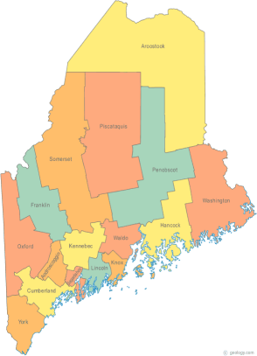 | Maine Continuum of Care (MCOC) Agenda  February 19, 2015 1:00 pm to 3:00 pm  Meeting at several locations via Tandberg Conferencing System.  - Turner Memorial Library, 39 2nd St., Presque Isle  - Torrey Hall Rm 111 UMM Campus, Machias  - Bangor – the library is not available. Please use the call in option below.  - Farmington Public Library, 117Academy Street, Farmington  - MaineHousing, 353 Water Street, Augusta  - Lewiston Public Library, 200 Lisbon Street, Lewiston  - Portland Public Library, 5 Monument Square, Portland  For those not able to join us at one of the Tandberg locations, the Tandberg system now includes an integrated call in option.  Please call in to 866-6497. This number will be unique to each meeting.
---Agenda Items---
- Member Introductions |  | All
- Review & Approval of minutes |  | All | Need to Vote
- Steering Committee |  | Chairs
- Project Committee |  | Chairs
- Scoring Committee |  | Chairs
- Resource Committee |  | Chairs
- Data Committee |  | Chairs
- Policy Committee |  | Chairs
- Federal & State Legislation |  | Cullen or Vickey
- Long Term Stayers Initiative |  | All
- Statewide Homeless Council |  | Cullen or Wes
- GIW |  | Paula/All
- Coordinated Assessment Update
- Performance Measures Overview
- Announcements & Updates
- Any Other Business
- Next Meeting
- March 19th, 1pm to 3pm
Please bring all e-mailed material to the meeting. Contact stibbitts@mainehousing.org for more information.

