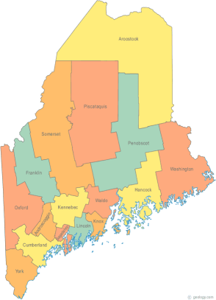 | MCOC Policy Committee  Minutes  Tuesday, November 18, 2014 4:00PM  Community Housing of Maine  309 Cumberland Ave., Suite 203  Portland, ME 04101  Call-in number 1-605-475-4350  Access Code: 810236# | All Committee Agendas and Minutes will be sent to MCOC Chairs by the 10th of each month for inclusion in materials sent to all members prior to each monthly MCOC meeting.
-Agenda Items-

- Welcome/Introductions/Attendance  Attendance: Vickey Rand, Ginny Dill, Awa Conteh, and Lucy Barnhart.  Unable to attend: Cullen Ryan, Chet Barnes and Donna Kelley | Group

- State and Federal Legislation Updates and Action Items  Please refer to the previously forwarded report. The highlights were reviewed. | Group

- Other Business  - There was discussion regarding the National Housing Trust Fund (NHTF), the 2014 Housing Policy Conference, and the recent mid-term elections.  - There was discussion regarding Shelter Plus Care. | Group

- Next Meeting (confirm time and location)/Adjournment
- Due to committee members being unable to attend during the regularly scheduled date/time, the Chairs will work to find an alternate standing meeting date/time for future meetings.
- The next meeting is scheduled for: TBA.

