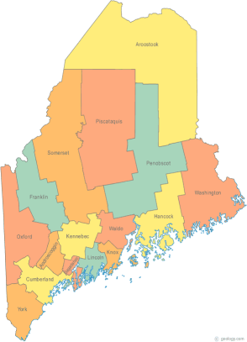 | Maine Continuum of Care (MCOC) Agenda  September 18, 2014 1p to 3pm  Meeting at several locations via Tandberg Conferencing System.  - Turner Memorial Library, 39 2nd St., Presque Isle (not back up till next month)  - Washington Academy, 66 High Street, East Machias  - Bangor Public Library, 145 Harlow Street, Bangor  - Farmington Public Library, 117Academy Street, Farmington  - Maine State Library, 230 State Street, Augusta  - *MaineHousing, 353 Water Street, Augusta*  (*New! Testing this month, Augusta meetings will be here starting next month!*)  - Lewiston Public Library, 200 Lisbon Street, Lewiston  - Portland Public Library, 5 Monument Square, Portland  Call in option – dial 1-866-316-1519 and enter code 9284295#
---Agenda Items---
- Member Introductions |  | All
- Review & Approval of minutes |  | All | Need to Vote
- Steering Committee – Review schedule for meeting dates/times |  | Chairs
- Project Committee |  | Chairs
- Scoring Committee |  | Chairs
- Resource Committee |  | Chairs
- Data Committee |  | Chairs
- Policy Committee |  | Chairs
- Coordinated Assessment & Project Monitoring / Evaluation |  | TAC – Melany Mondello
- Cloudburst Follow up (Reallocation) |  | Heather
- Announcements & Updates |  | All
- Any Other Business |  | All
- Next Meeting
- October 16, 2014
Please bring all e-mailed material to the meeting. Contact stibbitts@mainehousing.org for more information.

