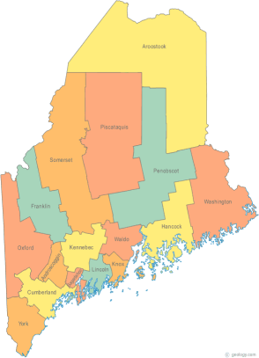 | Maine Continuum of Care (MCOC) Agenda  August 21, 2014 1pm to 3pm  Meeting at several locations via Tandberg Conferencing System.  - Turner Memorial Library, 39 2nd St., Presque Isle (not currently available)  - Washington Academy (not currently available)  - Bangor Public Library, 145 Harlow Street, Bangor  - Farmington Public Library, 117Academy Street (awaiting confirmation)  - Maine State Library, 230 State Street, Augusta  - Lewiston Public Library, 200 Lisbon Street, Lewiston  - Portland Public Library, 5 Monument Square (not currently available)  To participate via Conference Call line, Please dial  1-866-316-1519, when prompted enter code 9284295#
---Agenda Items---
- Member Introductions |  | All
- Review & Approval of minutes |  | All | Vote required
- Steering Committee  - MaineHousing Con Plan summary |  | Chairs
- Project Committee |  | All
- Scoring Committee |  | Chairs
- Resource Committee |  | Chairs
- Data Committee |  | Chairs
- Policy Committee |  | Chairs
- CSI – Grant Agreement Amendment (name change) |  | Steve Price | Vote required
- GIW |  | Paula
- Coordinated Assessment – TAC TA |  | Ginny, Betty
- Cloudburst TA - reallocation |  | Donna / Ginny
- Statewide Homeless Council |  | Cullen / Wes
- Announcements & Updates |  | All
- Next Meeting
- September 18, 2014
Please bring all e-mailed material to the meeting. Contact stibbitts@mainehousing.org for more information.

