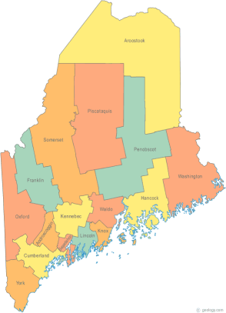 | MCOC Policy Committee  Minutes  Friday, May 30, 2014 10:00AM-11:00AM  Community Housing of Maine  309 Cumberland Ave., Suite 203  Portland, ME 04101  Call-in number 1-605-475-4350  Access Code: 810236# | All Committee Agendas and Minutes will be sent to MCOC Chairs by the 10th of each month for inclusion in materials sent to all members prior to each monthly MCOC meeting.
-Agenda Items-

- Welcome/Introductions/Attendance  Attendance: Cullen Ryan, Vickey Rand, Ginny Dill, Heather Rhoda, Chet Barnes, and Donna Kelley. Unable to attend: Awa Conteh | Group

- Chair/Co-Chair Nominations  Heather motioned to nominate Vickey as Chair. The motion was seconded by Ginny. All were in favor. Heather motioned to nominate Cullen as Co-Chair. The motion was seconded by Ginny. All were in favor. | Group

- State and Federal Legislation Updates and Action Items  Please refer to the previously forwarded report. The highlights were reviewed.  - On the federal level, there is a proposed $27 million cut to HOPWA | Group

- Other Business
- The National Alliance to End Homelessness (NAEH) Annual Conference is in late July. A group from Maine will be attending and meeting with the Delegation.
- The NAEH State of Homelessness in America 2014 report is available. Click here to view the report.
- The 100,000 Homes campaign announced this week that it is on target to reach its goal in June 2014.

- Next Meeting (confirm time and location)/Adjournment
- The committee agreed to meet every other month, and remain available in between meetings in the event an action item arises that requires the group’s swift action.
- The next meeting is scheduled for Tuesday, July 15th at 4:00 PM.

