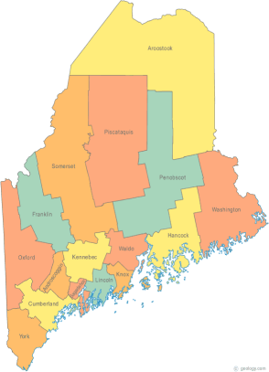 | A Special Meeting of the Ad Hoc Governance Committee will be held from 12:00-1:00 pm via Tanberg Conferencing System.  Maine Continuum of Care (MCOC) Agenda  March 20, 2014 1:00 pm to 3:00 pm  - Presque Isle High School ,CTE unit  - Bangor Public Library, 145 Harlow Street, Bangor  - Farmington Public Library, 117Academy Street, Farmington  - Maine State Library, 230 State Street, Augusta  - Portland Public Library, 5 Monument Square, Portland
---Agenda Items---
- Member Introductions |  | All
- Review/Approval of minutes |  | All
- Tandberg Conference Sites on Maine Homeless Planning Site  Do we need additional locations? |  | All
- Annual Point-in-Time, Housing Inventory, and Unmet Needs
- CoC Meeting Process and Operations (tabled from 2-20-14)
- Committees of MCOC  Schedules, Chairs, Members, Minutes |  | see MaineHousing Support to Maine CoC and MCOC Committee Membership for 2014
- Steering Committee
- HMIS Advisory Committee
- Project Committee

- Scoring Committee
- Resource Committee

- Data Committee

- Ad Hoc Governance Committee
- Policy Committee

- Statewide Homeless Council |  | Wes & Cullen
- Reallocation
- Work Plan Updates
- Any Other Business
- Next Meeting
-April 17, 2014 1pm to 3pm
Please bring all e-mailed material to the meeting. Contact stibbitts@mainehousing.org for more information.

