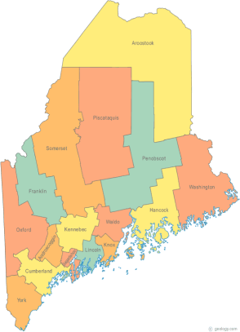 | Maine Continuum of Care (MCOC) Agenda  February 20, 2014 1:00 pm to 3:00 pm  MCOC will be meeting simultaneously at different  locations via the Tandberg Teleconferencing System.  - Presque Isle High School ,CTE unit  - Bangor Public Library, 145 Harlow Street, Bangor  - Farmington Public Library, 117Academy Street, Farmington  - Maine State Library, 230 State Street, Augusta  - Portland Public Library, 5 Monument Square, Portland
---Agenda Items---
- Member Introductions |  | All
- Review/Approval of minutes |  | All
- Old Business: Updates on work in progress |  | All
- NOFA De-Briefing

- CoC Meeting Process and Operations
- Adding a Call-In number or additional Tanberg sites to increase participation in full CoC meetings.
- Subcommittees need to reconvene, set schedules, chairs and note takers
- Discussion of NOFA work plan and planning grant |  | Chairs
- Nomination for tri-chair as Heather’s term is up (but she can be re-nominated).
- Reaffirm the chairs of all the committees
- Project Committee: discussion on making this two committees due to work
- Steering Committee
- Data Committee  - PIT and HIC updates |  | Ginny, Awa
- Resource Committee |  | Joe & Mike
- Policy Committee |  | Cullen
- Statewide Homeless Council |  | Wes & Cullen
- Other Business:
- Next Meeting
-March 20, 2014 1pm to 3pm
Please bring all e-mailed material to the meeting. Contact stibbitts@mainehousing.org for more information.

