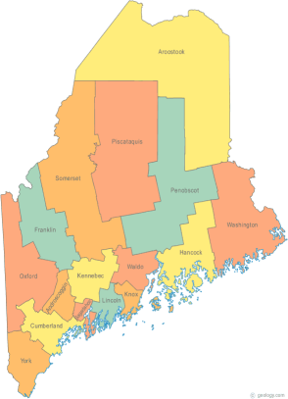 | Maine Continuum of Care (MCOC) Agenda  January 23, 2014 1:00 pm to 4:00 pm  WE WILL NOT BE USING THE LIBRARY ROOMS THIS TIME. THE MEETING WILL BE AT MAINEHOUSING, 353 Water Street IN AUGUSTA, OR YOU MAY JOIN BY “GO TO MEETING” FROM YOUR COMPUTER and call in to the conference number.  1. Please join my meeting. https://www1.gotomeeting.com/join/491854856  2. Join the conference call: Call in to 1-866-316-1519 When prompted, enter code 9284295#
---Agenda Items---
- Member Introductions |  | All
- Review/Approval of minutes |  | All
- NOFA Related Items: See Below

Section 1: Review Section 1a, b & c |  | Paula, All
Complete Section 1d
Need attachment for Section 1d for written documentation of ranking / selection process, etc.
Section 3: Finalize all projects for 2014 / 2015. Review narratives, etc.
Section 4: Review the 6 questions in 4a to completion, etc.
- Ranking / Selection process narrative
- Next meeting
Feb 20, 2014

Please bring all e-mailed material to the meeting. Contact stibbitts@mainehousing.org for more information.

