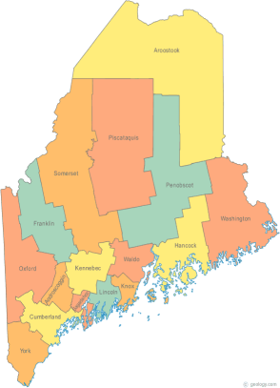 | Meeting of the Maine Continuum of Care  September 17, 2020 1:00 pm to 3:00 pm  Meeting via GoTo Meeting ONLY!!!!  There will be no group gathering locations this month.  GoToMeeting information for joining the meeting from your computer, tablet or smartphone is listed below:  https://global.gotomeeting.com/join/352415877  To join via phone, call: +1 (646) 749-3122 Access Code: 352-415-877  (Please use either your phone or your computer audio to connect – do not use both!  Email blabua@mainehousing.org to let us know when you attend!)
---Agenda Items---
- Member Introductions |  | All
- Review & Approval of minutes* |  | All | *Need to Vote
- Big Thinking Topics:  - How to get GA to enter info into HMIS – Continued Discussion  - COVID-19 – Continued Discussion |  | All
- State and Federal Legislation |  | Cullen
- Statewide Homeless Council Update |  | Steph Primm
- Long Term Stayers Update |  | All
- CoC Board Update  - General updates & any decisions made by the BOD – Standing agenda item  - Strategic Planning Update – Standing agenda item  - Coordinated Entry Update – Standing agenda item |  | All
- Brief Standing Committee Updates:  - Brief, pertinent Committee updates as applicable |  | All
- Next Agenda – Items for next month |  | All
- Any Other Business
Next Meeting: October 15, 2020 1pm to 3pm
Please read all materials prior to attending the meetings in order to be prepared to participate in the discussion.
Materials posted at www.mainehomelessplanning.org Contact blabua@mainehousing.org for more information.

