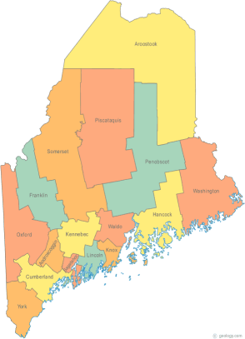 | Meeting of the Maine Continuum of Care  January 16, 2020 1:00 pm to 3:00 pm  Meeting at THREE locations via GoTo Meeting  - MaineHousing, 353 Water St, Augusta  - New Beginnings, 134 College Street, Lewiston  - Shalom House, 106 Gilman Street, Portland  Please try to attend at one of the group sites listed above. For those unable to attend a designated group site in person, GoTo Meeting information for joining the meeting from your computer, tablet or smartphone is listed below. If you want to setup a group site at your agency let Scott know!  https://global.gotomeeting.com/join/352415877  To join via phone, call: +1 (646) 749-3122 Access Code: 352-415-877  (Please use either your phone or your computer audio to connect – do not use both!)
---Agenda Items---
- Member Introductions |  | All
- Review & Approval of minutes*  A word about recent HUD announcements |  | All | *Need to Vote
- Big Thinking Topic:  - Chair Nominations*  - Project Monitoring Process/Forms* |  | All | *Need to Vote
- State and Federal Legislation |  | Cullen
- Statewide Homeless Council Update |  | Steph Primm
- Long Term Stayers Update |  | All
- CoC Board Update  - Board Vacancies*  - General updates & any decisions made by the BOD – Standing agenda item  - Strategic Planning Update – Standing agenda item  - Coordinated Entry Update – Standing agenda item |  | All | *Possible Need to Vote
- 2020 PIT – Standing agenda item |  | All
- Brief Standing Committee Updates:  - Brief, pertinent Committee updates as applicable |  | All
- Next Agenda – Items for next month |  | All
- Any Other Business
Next Meeting: February 20, 2020 1pm to 3pm
Please read all materials prior to attending the meetings in order to be prepared to participate in the discussion.
Materials posted at www.mainehomelessplanning.org Contact stibbitts@mainehousing.org for more information.

