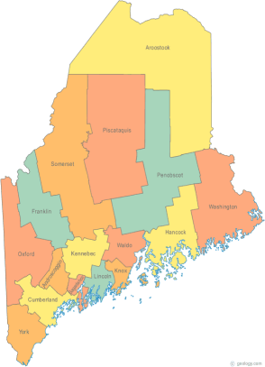 | Meeting of the Maine Continuum of Care  April 18, 2019 1:00 pm to 3:00 pm  Meeting at FOUR locations via GoTo Meeting – NEW  - MaineHousing, 353 Water St, Augusta  - New Beginnings, 134 College Street, Lewiston  - Shalom House, 106 Gilman Street, Portland  - PCHC Admin Building, 103 Maine Ave, Bangor  Since this is the first meeting using GoTo Meeting instead of Tandberg, please try to attend at one of the group sites listed above. For those unable to attend a designated group site in person, GoTo Meeting information for joining the meeting from your computer, tablet or smartphone is listed below:  https://global.gotomeeting.com/join/352415877  To join via phone, call: +1 (646) 749-3122 Access Code: 352-415-877  (Please use either your phone or your computer audio to connect – do not use both!)
---Agenda Items---
- Member Introductions |  | All
- Review & Approval of minutes* |  | All | *Need to Vote
- MCOC Chair Vacancy Nominations* |  | Chairs | *Possible Need to Vote
- Big Thinking Topics –  - “Move On Strategies” discussion in preparation for the NOFA |  | All | *Need to Vote
- State and Federal Legislation |  | Cullen
- Statewide Homeless Council Update |  | Cullen
- Regional Homeless Council Updates |  | All
- Long Term Stayers Update |  | All
- CoC Board Update  - MCoC NAEH Conference Scholarship Opportunity Update  - Strategic Planning Update – Standing agenda item  - Coordinated Entry Update – Standing agenda item |  | All
- NOFA Related updates:  - The GIW is out and was due back to HUD April 17th!  - The (already twice extended) LSA deadline is April 22nd!  - The PIT and HIC deadlines are April 30th!  - The NOFA is expected to be released in early May!  - The YHDP Application deadline is May 15th!  - The Gaps and Needs study is underway! |  | Scott
- Family & Youth Services Bureau upcoming NOFA for street outreach – letters of support* |  | All | *Need to Vote
- Letter of Support Request – Veterans, Inc. HVRP |  | Brendon | *Need to Vote
- Brief Standing Committee Updates:  - Update on Committee Charters, inclusion of Committee information, minutes, and materials with MCOC ,meeting materials  - Brief, pertinent Committee updates as applicable |  | All
- Any Other Business |  | All
Next Meeting: May 16, 2019 1pm to 3pm
Please read all materials prior to attending the meetings in order to be prepared to participate in the discussion.
Materials posted at www.mainehomelessplanning.org Contact stibbitts@mainehousing.org for more information.

