The Maine Continuum of Care
and the Region II Homeless Council Presents

Social Security Disability Claims and Finding Success through SOAR
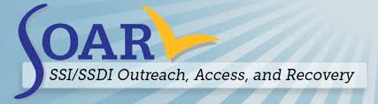
Presenters:
Preble Street VHS Staff

Friday December 14th, 2018
9-10am
Maine Housing Board Room, 353 Water St. Augusta
(The regular Region II Homeless Council meeting will begin directly after the training at 10 am)
SSI/SSDI Outreach, Access, and Recovery (SOAR) is a nationally recognized program designed to increase access to SSI/SSDI for eligible adults who are experiencing or at risk of homelessness** and have a serious mental illness, medical impairment, and/or a co-occurring substance use disorder.

Join us in a discussion about:
- Understanding eligibility for SSDI and SSI benefits
- How the SOAR program works in Maine to increase communication with the Social Security Administration and encourage successful claims
- Learn how to overcome common pitfalls with SSA applications

Who would benefit from attending?
- Shelter staff, school personnel, prison and jail system staff, social workers, case managers, or other providers working with adults and youth with disabilities.
- Anyone interested in learning more about how to better support their clients with their social security applications.

Sponsored by Maine CoC Resource Committee and the Region II Homeless Council

