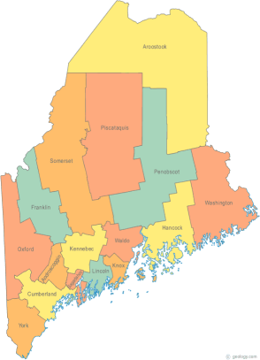 | Meeting of the Maine Continuum of Care  August 16, 2018 1:00 pm to 3:00 pm  Meeting at SIX locations via Tandberg Conferencing System.  Meeting Available at up to Seven locations via Tandberg Conferencing System.  - NEW LOCATION - Sweetser, 329 Bath Road, Brunswick  - Turner Memorial Library, 39 2nd St., Presque Isle (call ahead to let them know)  - Farmington Public Library, 117 Academy Street, Farmington (call ahead to let them know)  - MaineHousing, 353 Water St, Augusta  - Lewiston Public Library, 200 Lisbon Street, Lewiston  - Portland Public Library, 5 Monument Square, Portland  - Bangor Public Library, 145 Harlow St. Bangor  THE CALL-IN ONLY NUMBER FOR THIS MEETING IS 866-6426.  If you are at a Tandberg Location, use the system audio, not the call in #.  And please – only use the call in if you cannot make it to a Tandberg site.
---Agenda Items---
- Member Introductions |  | All
- Review & Approval of minutes |  | All | Need to Vote
- 2019 Annual Action Plan – Draft |  | Paula Weber
- Big Thinking Topic – FY 18 NOFA – All things NOFA  - Review and approve Nominees for Selection committee  - Review and approve proposed scoring template for renewal & new projects  - Review proposed ranking protocol  - Review proposed appeals process |  | All | Need to vote
- NAEH 2018 Ending Homelessness Conference – Update |  | Cullen
- State and Federal Legislation |  | Cullen
- Statewide Homeless Council |  | Cullen
- Regional Homeless Council Updates |  | All
- Long Term Stayers Update |  | All
- CoC Board Update  - Strategic Planning Update – Standing agenda item  - Coordinated Entry Update – Standing agenda item  - Board Vacancies – Consider DV and Veteran nominations |  | All | Need to Vote
- Brief Standing Committee Updates:  - Data  - Project/Monitoring  - Policy  - Resource  - Special Populations:  - Veterans  - Youth |  | All
- Any Other Business |  | All
Next Meeting: ** September 13, 2018, 1pm to 3pm**
**Please note this is a rescheduled date in order to review the NOFA and related materials prior to submission**
Please read all materials prior to attending the meetings in order to be prepared to participate in the discussion.
Materials posted at www.mainehomelessplanning.org Contact stibbitts@mainehousing.org for more information.

