Policy/Advocacy Update – 6/22/2018

Federal Legislation Update:
New – House Budget Committee FY 19 Budget Resolution – On 6/21 the House Budget Committee passed its FY 19 Budget Resolution, titled “A Brighter American Future,” in a 21-13 vote. The Budget Resolution lays out trillions of dollar in spending cuts – $8 trillion from federal deficits over the next decade, with $5.4 trillion of that from changes to entitlement programs including Medicare ($537 billion cut over the next decade) and Social Security ($4 billion cut over the next decade). The budget resolution also essentially repeals the ACA and makes large changes and cuts to Medicaid – limiting per capita caps and/or allowing states to implement a block-grant program (the same approach taken in the failed ACA repeal/replace bill last year). The changes to Medicaid and other health programs would total to approximately $1.5 trillion in cuts. The future of the bill is unclear, as Republican leaders haven’t committed to bringing the bill to the floor.
New – Trump Administration Rescissions Package – On 6/21 the Senate voted to reject the $15 billion rescissions package, in a close 50-48 vote – with Senators Collins and Burr being the only two Republicans to vote against the bill, along with all Democrats present. The House had passed the bill in March. The bill would have taken back $15 billion in spending already approved and appropriated. Per the Washington Post, independent analysis found that approximately $1 billion of the $15 billion in the rescission package would have been actually cut, as the rest would have not been spent.
New – ACA Repeal Plan – A new plan to repeal the Affordable Care Act (ACA) was announced on 6/19 by the Health Policy Consensus Group, which includes representatives from conservative think tanks as the Heritage Foundation, American Enterprise Institute, Galen Institute and the Manhattan Institute (according to the Wall Street Journal). Per the CBPP, the new plan would have the same effects on health insurance coverage, access to care, and many Americans’ health and financial security as last year’s repeal bills. It would:
- Eliminate the ACA’s Medicaid expansion for low-income adults;
- Lead to sharply increased health care costs for millions of moderate-income individual-market consumers – especially older people;
- Eliminate consumer protections that are especially crucial for people with pre-existing health conditions; and
- Cause millions to lose coverage.
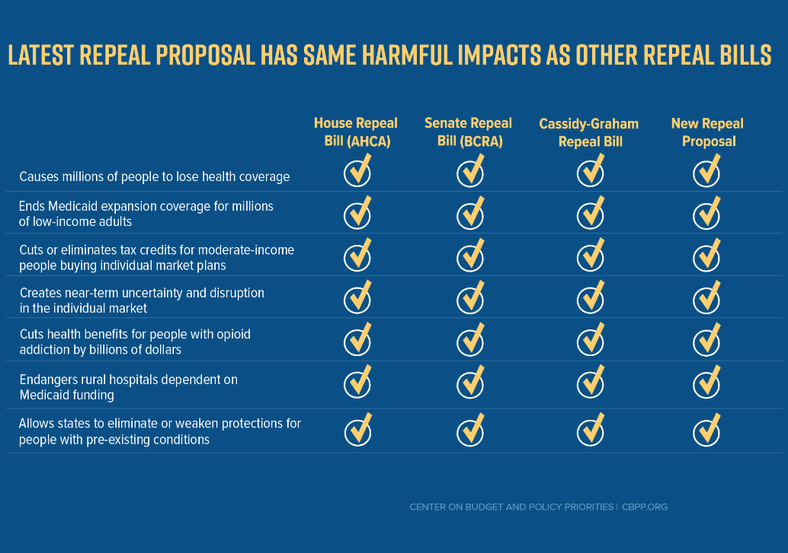

New – Trump Administration Rules Re. the ACA – Per the CBPP, the Administration issued of a final rule expanding Association Health Plans, a rule that will also weaken (though not eliminate) protections for people with pre-existing conditions. According to Vox, with this change, many small businesses and self-employed individuals will be able to purchase policies which not be required to cover all of the essential health benefits mandated by the Affordable Care Act.
H.R. 2: Agriculture and Nutrition Act of 2018 – Update – On 6/21 the House approved its Farm bill, which will eliminate or reduce food assistance for more than 1 million low-income households comprised of more than 2 million people, according to the CBPP. Also per the CBPP, “the bill would expand SNAP’s existing work requirements, imposing new rules on millions of participants. It would require participants ages 18-59 who aren’t disabled or raising a child under 6 to prove — every month — that they’re working at least 20 hours a week, participating at least 20 hours a week in a work program, or a combination of the two. Those who couldn’t comply would face harsh sanctions. The first sanction for non-compliance would mean a loss of the person’s share of the household benefit for 12 months. Each later infraction would lock people out of SNAP for 36 months.”

The Senate Agriculture Committee’s draft Bipartisan Farm Bill – New – The bill would reauthorize SNAP and improve the program’s integrity and operations, according to CBPP. Also according to CBPP, the bill would also expand the 2014 farm bill’s pilot program to test promising approaches to job training and other employment-related activities for SNAP participants and would make targeted investments that would help seniors and people with disabilities. This bill reaffirms SNAP’s importance for struggling households that can’t afford a basic nutrition without it’s help. Per CBPP, it stands in stark contrast to the House farm bill’s SNAP provisions, which would end or cut benefits for more than 2 million people in more than 1 million households. The Senate could take up the bill as early as the week of 6/25.

FY 18 Budget: Appropriators have negotiated a final FY 18 omnibus spending bill; the House passed the bill on 3/22, the Senate following suit in the early hours of 3/23, and the President signed the bill later in the day, avoiding a government shutdown. The budget includes a $4.6 billion increase to HUD vs. FY 17 funding (budget amounts reflected in the chart below).
LIHTC improvements & expansion as part of the omnibus bill: Per the NLIHC: The omnibus includes a 12.5% increase in Low Income Housing Tax Credits for four years and the permanent authorization of income averaging, which could increase the ability of the tax credit to reach the lowest income households. These changes could help offset the impact of the lowered corporate tax rate from 35% to 21%, which effectively reduces the value of Housing Credits to corporate investors.

HUD Policy Changes (rent increases/work requirements) –T he Administration released a legislative proposal on 4/25 that would raise rents on low-income people with HUD rental assistance and allow housing agencies and subsidized owners to impose work requirements. According to the CBPP, the rent increases will ultimately total $3.2 billion a year. Working families, the elderly, and people with disabilities would pay more than 3/4s of that increase.
The proposal would raise rents in three main ways: 1) Tripling the minimum rents (from $50 to $150), affecting the poorest rental assistance recipients; 2) charging households with adults who aren’t elderly or disabled 35% of their income for rent instead of 30%; and 3) eliminating deductions such as those for child care and high out-of-pocket medical expenses. Per the NLIHC, the legislation would also allow the HUD secretary to impose even higher rents through alternative rent structures and de facto time limits.
Per CBPP, the rent increase’s effect on Maine would be as follows:
Households affected | Average Annual Rent Increase Per Household | Total Annual Rent Increase
24,600 | $600 | $14,688,000

House FY19 THUD Appropriations bill – Update – The House THUD Appropriations Committee released the first draft of its FY 19 spending bill, which according to the NLIHC, provides significant funding to housing programs that serve low income people and communities. According to the CBPP, the bill doesn’t fully fund the renewal of housing vouchers and other rental assistance now in use. The CBPP approximates that these renewal shortfalls would leave nearly 50,000 housing vouchers that seniors, families, and others are currently using without renewal funds in 2019. The subcommittee first took up the bill May 16; the full Committee moved the bill forward on 5/23. It now goes to the full House for consideration. The bill:
- Maintains the 10% increase in HUD funding that advocates and Congressional champions secured in FY18 with modest additional increases for FY19;
- Clearly rejects the president’s call to drastically cut housing investments.
- Provides HUD programs with more than $11 billion above the president’s FY19 request.
- Rejects the rent increases, work requirements, and de facto time limits proposed by the president in his FY19 budget request and in subsequent legislation.
The House subcommittee bill provides increased or level funding to most programs, with the exception of HCV and PBS8:
- Housing Choice Vouchers: $20.1 billion (not predicted to be sufficient to renew all existing contracts)
- Project-Based Section 8: $11.35 billion (not predicted to be sufficient to renew all existing contracts)
- HOPWA: $393 million (modest increase)
- Homeless Assistance Grants: $3.55 billion (modest increase)
- Public housing: $2.8 billion for capital repairs and $4.6 billion for operating (funded at the increased levels provided in FY18)
- Choice Neighborhoods: $150 million (funded at the increased levels provided in FY18)
- CDBG: $3.37 billion (funded at the increased levels provided in FY18)
- Section 202 Housing for the Elderly: $632 million (sufficient to renew existing contracts)
- Section 811 Housing for People with Disabilities: $154 million
- HOME: $1.2 billion (decrease from FY 18, an increase from previous years’ funding).
- $50 million in new resources for a mobility-voucher demonstration for families with young children to help them move to areas of opportunity
- $100 million in competitive grants to Native American communities to spur construction and preservation of affordable rental housing.
Senate FY19 THUD Appropriations bill – Update – The Senate Committee on Appropriations voted on 6/7 to approve a draft FY 19 bill that includes robust funding for HUD, according to the NLIHC. Per the CBPP the bill provides $54 billion for HUD programs in FY 19, about $1.3 billion above HUD’s FY 18 budget and $855 million above the House bill. The bill’s highlights include:
- Section 8: Full renewal funding for housing vouchers ($20.5 billion, $920 million about FY 18 funding and $400 million above the House bill).
  - $20 million for approximately 2,000 new Family Unification Program (FUP) vouchers targeted to youth;
  - $40 million for approximately 5,000 new VASH vouchers
  - $154 million for mainstream vouchers (VNEDs), a much as $39 million of which may be available for new vouchers (depending upon the final cost of renewing vouchers in FY 19);
- Homeless Assistance Grants: $2.6 billion, $99 million above FY 18 funding levels. This includes $80 million for youth initiatives and $50 million for RRH for victims of domestic violence.
- CDBG: $3.3 billion, consistent with FY 18 funding
- HOME: $1.362 billion, consistent with FY 18 funding
- USICH: $3.6 million, consistent with FY 18 funding.
The Senate bill does not include any of the proposed administrative reforms to HUD’s rental assistance programs that would increase rents.
President Trump’s FY 19 Budget – President Trump unveiled his FY 19 budget request on 2/12. The budget would cut HUD by an astounding $8.8 billion or 18.3% compared to the 2017 enacted levels. In an addendum stemming from the bipartisan budget agreement, the President suggests that $2 billion above his request could be added back in for a final proposed cut of $6.8 billion. Such a reduction could lead to at least 200,000 housing vouchers being lost.
HUD Programs (set asides italicized)  (In millions) | FY17  Final | FY18  President | FY18  House | FY18  Senate | FY18  Final | FY19  President^
Tenant Based Rental Assistance | 20,292 | 19,318 | 20,487 | 21,365 | 22,015 | 19,315
Contract Renewals | 18,355 | 17,584 | 18,710 | 19,370 | 19,600 | 17,514
Tenant Protection Vouchers | 110 | 60 | 60 | 75 | 85 | 140
Administrative Fees | 1,650 | 1,550 | 1,550 | 1,725 | 1,760 | 1,550
Section 811 Mainstream Vouchers | 120 | 107 | 150 | 130 | 505 | 107
VASH Vouchers | 40 | 0 | 577* | 40 | 40 | 0
Tribal VASH Vouchers | 7 | 7 | 7 | 5 | 5 | 4
Family Unification | 10 | 0 | 0 | 20 | 20 | 0
Project-Based Rental Assistance | 10,816 | 10,351 | 11,082 | 11,507 | 11,515 | 10,866
Homeless Assistance Grants | 2,383 | 2,250 | 2,383 | 2,456 | 2,513 | 2,383
Public Housing Capital Fund | 1,942 | 628 | 1,850 | 1,945 | 2,750 | 0
Public Housing Operating Fund | 4,400 | 3,900 | 4,400 | 4,500 | 4,550 | 2,841
Choice Neighborhoods Initiative | 138 | 0 | 20 | 50 | 150 | 0
Family Self Sufficiency | 75 | 75 | 75 | 75 | 75 | 75
HOPWA | 356 | 330 | 356 | 330 | 375 | 330
Community Development Fund | 3,060 | 0 | 2,960 | 3,060 | 3,365 | 0
CDBG Formula Grants | 3,000 | 0 | 2,900 | 3,000 | 3,300 | 0
HOME Investment Partnerships | 950 | 0 | 850 | 950 | 1,362 | 0
Rental Assistance Demonstration | 0 | 0 | 0 | 4 | 0 | 100

National Housing Trust Fund – The HTF is the only federal program designed to build and preserve housing affordable to people with the lowest incomes. President Trump proposed to eliminate the HTF in his FY19 budget request.
S. 1835: Lower Premiums Through Reinsurance Act of 2017 – No New Update. Sponsored by Senator Collins. This bill would give states some options--including options in the style of Maine's "PL 90" invisible high-risk pool that was in effect briefly before the ACA was passed--for stabilizing insurance markets.
S. 743: A Bill to Strengthen the United Stated Interagency Council on Homelessness No New Update. Senators Collins and Reed introduced legislation on 3/28 to strengthen and eliminate the sunset for the U.S. Interagency Council on Homelessness (USICH). Referred to the Senate Committee on Banking, Housing, and Urban Affairs.
H.R. 161: Services for Ending Long-Term Homelessness Act – No New Update. Sponsored by Representative Hastings (Florida). This bill would amend the Public Health Service Act to establish a grant program to provide supportive services in permanent supportive housing for chronically homeless individuals and families, and for other purposes. Referred to the House Energy and Commerce committee.
H.R. 948: The Common Sense Housing Investment Act of 2017. – No New Update. Sponsored by Rep. Keith Ellison. To amend the Internal Revenue Code of 1986 to replace the mortgage interest deduction with a nonrefundable credit for indebtedness secured by a residence, to provide affordable housing to extremely low-income families, and for other purposes.
H.R. 2076: Ending Homelessness Act of 2017 – No New Update. Introduced on 4/6 by House Financial Services Committee Ranking Member Maxine Waters (D-CA).
On 2/23, Financial Services Committee Ranking Member Maxine Waters requested that the Government Accountability Office (GAO) conduct a study on the state of homelessness in America. Rep. Waters specifically asked that the GAO research how the shortage of affordable housing impacts homelessness, saying the report will “better equip [Congress] in [its] efforts to prevent and end homelessness in this country.” Rep. Waters also identifies several other issues that the report should examine, including factors that increase homelessness and the policies, tools, and funding levels to effectively address those factors; the impact of current programs on various sub-populations, like families with children and individuals with substance-abuse disorders; current methods for estimating homelessness; and the ability of federal programs to utilize non-federal resources.
S. 2571: The Runaway and Homeless Youth and Trafficking Prevention Act (RHYTPA). Referred to the Committee on the Judiciary. Sponsored by Senators Susan Collins and Patrick Leahy (D-VT). (House companion bill: H.R. 5539 sponsored by Congressman Yarmuth (D-KY), Congressman Denham (R-CA), and Congressman Reichert (R-WA)). The reintroduced bipartisan bill to curb youth homelessness and support young victims of trafficking. The bill would reauthorize the Runaway and Homeless Youth Act programs and continue authority for grants to communities across the nation to prevent and respond to youth and young adult homelessness.
H.R. 5833: Expanding Housing Opportunities for Foster Youth Act of 2018 – New On 5/16 House Financial Services Committee Ranking Member Maxine Waters (D-CA) introduced the. This bill would permanently reauthorize $200 million annually for HUD’s Family Unification Program (FUP), which helps provide stable housing for young people transitioning out of foster care.
New – On 5/24 the President signed the Family Self-Sufficiency Act into law. The FSS law permanently reauthorizes the program, combines the FSS programs for Housing Choice Vouchers and public housing, which currently run separately, and expands eligibility to include families in privately owned properties subsidized with HUD project-based rental assistance. The program also offers new services for financial literacy and educational attainment.
H.R. 5793: The Housing Choice Voucher Mobility Demonstration Act of 2018 – New – According to the NLIHC, this bill, if enacted, would further improve voucher mobility to help more households using housing vouchers move to communities of their choice. On 5/22 the House Financial Services Committee approved the bill.
New – The three Affirmatively Furthering Fair Housing (AFFH) notices that HUD informally announced on 5/18 were formally published in the Federal Register on 5/23. Through these notices, HUD has in effect indefinitely suspended implementation of the 2015 AFFH rule.
S. 611/H.R.1511: Homeless Children and Youth Act of 2017 - New – This bill would amend the McKinney-Vento Homeless Assistance Act to modify definitions relating to individuals experiencing homelessness, and children or youth experiencing homelessness as used by HUD to verify eligibility for HUD homeless assistance programs, to align them with the definitions of "homeless" used to verify eligibility for other federal assistance programs. Per the bill’s summary, the amended definitions would increase access to federal homeless programs by children, youth, and families experiencing homelessness. The House Financial Services Committee held a subcommittee hearing on the bill on 6/6.
H.R. 5735 – THRIVE Act – New – Introduced by Representative Andy Barr (R-KY) – This bill amends the United States Housing Act of 1937 to require the Department of Housing and Urban Development to establish a five-year demonstration program for nonprofit organizations to provide low-income rental-assistance vouchers to individuals recovering from an opioid or other substance-use disorder. Specifically, an organization shall provide these vouchers through a supportive and transitional housing program that provides treatment for such disorders and job skills training for a period of 12 to 24 months. According to the NLIHC, this bill would divert 10,000 vouchers, or $83 million, away from the Housing Choice Voucher program to pay for transitional recovery housing for people with substance-use disorders. The House voted on 6/14 to approve this bill. The bill now heads to the Senate for consideration.

State Legislation Update: The Legislature convened a Special Session on 6/19. On 6/20 & 6/21, the Legislature enacted two supplemental budget bills (LD 924 and 925), which now go to the Governor (who has the option of line-item veto). These supplemental budget bills include funding for people with disabilities, the elderly, or people with opioid use disorders.

- LD 1711 An Act To Save Lives and Create the Homeless Opioid User Service Engagement Pilot Project, sponsored by Rep. Gattine. -Was exempted from the Table and passed by the Legislature on 6/21. It now goes to the Governor.

The following bills are still on the Special Appropriations Table, will die on the Table unless addressed in a Special Session:
- LD 1713 An Act To Improve Housing Support in the Bridging Rental Assistance Program, sponsored by Rep. Gattine.
- LD 1682 An Act To Ensure the Quality of and Increase Access to Recovery Residences.

