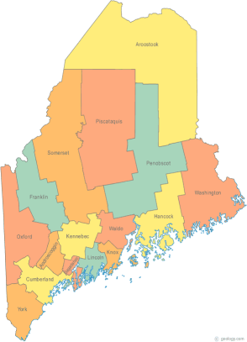 | Meeting of the Maine Continuum of Care  April 19, 2018 1:00 pm to 3:00 pm  Meeting at SIX locations via Tandberg Conferencing System.  - Turner Memorial Library, 39 2nd St., Presque Isle (call ahead to let them know)  - Farmington Public Library, 117 Academy Street, Farmington (call ahead)  - MaineHousing, 353 Water St, Augusta  - Lewiston Public Library, 200 Lisbon Street, Lewiston  - Portland Public Library, 5 Monument Square, Portland  - Bangor Public Library, 145 Harlow St. Bangor  THE CALL-IN ONLY NUMBER FOR THIS MEETING IS 866-6433.  If you are at a Tandberg Location, use the system audio, not the call in #.  And please – only use the call in if you cannot make it to a Tandberg site.
---Agenda Items---
The April 19th MCOC Meeting will be entirely devoted to …
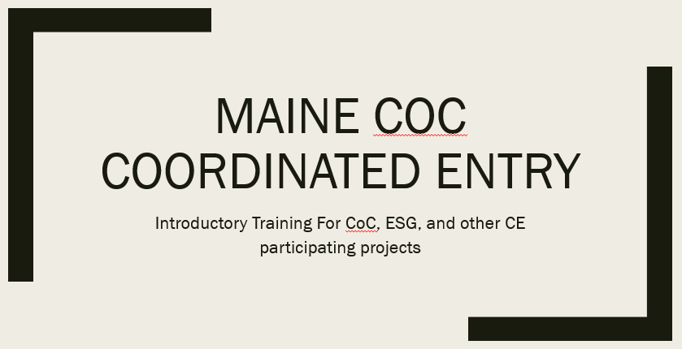

If there are people at your agency who do not ordinarily attend MCOC, but will be working with or have an interest in Maine’s Coordinated Entry System, please share this information with them and encourage them to attend this important training!

If you will be attending at one of the Tandberg Teleconferencing locations, you will be able to see and hear the presentation on the screen and ask questions (please mute your microphone when not asking a question in order to minimize background noise).

For those not able to make it to one of the Tandberg sites, you may join via “Go To Webinar” from your computer, tablet, or smart phone by clicking on the link below. (Save this agenda electronically so you can access the link!) Please note that the Webinar automatically mutes all participants, but you may submit questions and comments using the built in Chat feature, or you may phone the call in only number at the top, but again, please mute when not talking.

https://global.gotowebinar.com/eojoin/6444273224907753731/2604242059059953665

Next MCOC Meeting: May 17, 2018, 1pm to 3pm
Please read all materials prior to attending the meetings in order to be prepared to participate in the discussion.
Materials posted at www.mainehomelessplanning.org Contact stibbitts@mainehousing.org for more information.

