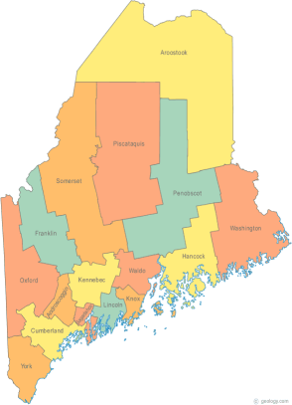 | MCOC Resource Committee Minutes  June 2, 2017 – 9:30-11:30  Family Violence Project  83 Western Ave.  Augusta, ME  Conference Bridge 1-844572-5683 ext. 4237499 | All Com Agendas and Minutes will be sent to MCOC Chairs by the 10th of each month for inclusion in materials sent to all members prior to each monthly MCOC meeting.
-Agenda Items- | Assigned to… | Due Date

- Welcome/Introductions/Attendance
Mike Mooney
Dan Fleming (new member from Shaw House)
Janice Lara-Hewey

II. Approval of Agenda/Additions/Adjustment | Agreed

III. Review/Approval of Minute  Approval of Minutes | Agreed

IV. Updates on Action Items assigned at prior meeting  Reviewed Region II training plans through September. Cullen Ryan will do a training and lead a discussion to get feedback on Maine’s revised “Plan to End and Prevent Homelessness” at the June Meeting. Maine Equal Justice Partners (MEJP) will do a training on the policy implications from 2017 legislation and a look forward at what future legislation is possible in the next legislative session that may impact services for low income Mainers. Mike will bring a copy of the MEJP application to the next Resource Committee meeting. | Mike | June 9th  July7th

V. New Business  Point in Time Count (PIT Count) Janice expressed concerns that the work of the unsheltered PIT count needs more of a scheduled structure throughout the year in case some of the current leaders on this effort are not available in the future. Janice is recommending making PIT planning a quarterly agenda item at the full COC meetings. Janice distributed a schedule and structure for these quarterly planning discussions. Janice will get Mike a copy of her proposal. Mike will present this idea to the Steering Committee. Goal will be to cover methodology at the June 15th COC meeting.  Resource Committee Goals for 2017 We reviewed the description of the Resource Committee in the COC governance document to provide some context for goal setting for this committee.  We agreed on the following goals for the remainder of 2017:  - Rewrite MCOC 101 to include statewide COC merger.  - Continue quarterly trainings at the Region II Homeless Council.  - Recruit a contact at the Region I & III Homeless Councils that will lead efforts of the Resource Committee to meet the training needs in Region I & III. This may or may not replicate what we have been doing in Region II. We all agreed the effort should be locally driven. At this point Dan Fleming has said he will spearhead this effort in Region III.  - Create a quarterly schedule at the COC meetings with agenda items dedicated to organizing and planning for the annual PIT.  - Provide orientation to new members of the COC as needed. Offer to direct people with questions about COC business to the appropriate resources.  - Work with Maine Housing to improve Maine Homeless Planning website. Develop a list of ways to make it more user friendly and increase enrollees. (e.g. Committee membership updates, Calendar of meetings around the state, etc.)  - Recruit new members to the Resource Committee, especially from Region I & III.  At the next meeting we will work on timelines for implementing these goals. | Mike and Janice  Dan  ALL | June 15th  July 7th

VII. General Discussion/Information Items

VII. Next Meeting, July 7th 9:30-11:30 am.
Family Violence Project
83 Western Ave.
Augusta, ME
Conference Bridge 1-844572-5683 ext. 4237499

Agenda:
- Review Region II training in June
- Updates from Region III
- PIT count sustainability / COC agenda
- September training for Region II Homeless Council -MEJP
- Develop plans and timelines for Goals over the next year

