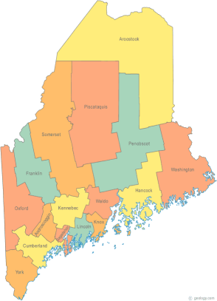 | MCOC Resource Committee Minutes  April 7, 2017 – 9:30-11:30  Family Violence Project  83 Western Ave.  Augusta, ME  Conference Bridge 1-844572-5683 ext. 4237499 | All Com Agendas and Minutes will be sent to MCOC Chairs by the 10th of each month for inclusion in materials sent to all members prior to each monthly MCOC meeting.
-Agenda Items- | Assigned to… | Due Date

- Welcome/Introductions/Attendance
Mike Mooney
Beth Crowe
Alley Smith

II. Approval of Agenda/Additions/Adjustment | Agree

III. Review/Approval of Minute  Approval of Minutes | Agreed

IV. Updates on Action Items assigned at prior meeting  Reviewed Evals from 3/10 training. Some people want us to go more into depth or maybe longer. Some asked us to be more clear about the audience. Some people want Housing 101 and some want more advanced…all levels of knowledge at the training  We’re looking for an update on Coordinated Entry pilot. Beth will reach out to Josh. | Beth | June 2nd

V. New Business  Future trainings- Reg 2 will discuss needs next Friday. Perhaps Maine Equal Justice can report on the legislation that passed. Mike and Alley will attend Region2 and participate in discussion to get feedback from members.  Snacks at Reg2 training, MHA supplies coffee and tea. Members of this committee have been purchasing muffins and fruit. That can become a burden. We decided not to do that anymore. Homeless Vet’s Action System is using it now.  Alley would like an orientation packet | Mike & Alley

VII. General Discussion/Information Items  Veteren’s Inc is more involved with PIT. Counted 89 homeless veterans.  New Beginnings has hired Topher Balderis as new staff.  We will set goals for next year once we know the CoC mission. | Mike

VII. Next Meeting, June 2nd 9:30-11:30 am.
Family Violence Project
83 Western Ave.
Augusta, ME
Conference Bridge 1-844572-5683 ext. 4237499

Agenda:
PIT count sustainability
June training
Goals for next year

Additional Instructions: Beth will be on vacation. FVP staff will let you in. Make yourself at home.-Beth

