The Region II Homeless Council Presents
Youth Homelessness
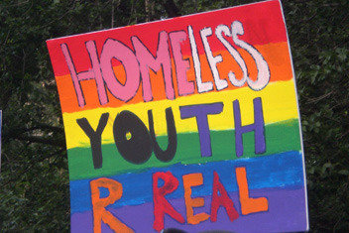
Presenters:
Homeless Youth Providers from Kennebec Behavioral Health & New Beginnings
Friday, December 9th, 9:00-10:30
Maine Housing in Augusta
353 Water St, Augusta, ME
(The regular Region II Homeless Council meeting will begin directly after the training from10:30 – 12:00)
Learn More About:
- Causes of Youth Homelessness
- Survival Strategies for Youth Experiencing Homelessness
- Developmental Issues/Unique Challenges in Serving Homeless Youth
- Barriers to Services
- Resources and Interventions
Who would benefit from attending?
- Case Managers
- Direct Services Staff
- School Personnel
- Anyone interested in learning more about this population
Sponsored by Maine CoC Resource Committee, Region II Homeless Council and Hosted by Maine Housing,

