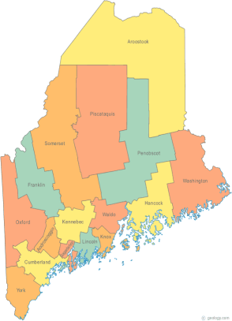 | Maine Continuum of Care (MCOC) Agenda  August 18, 2016 1:00 pm to 3:00 pm  Meeting at SIX locations via Tandberg Conferencing System.  - Turner Memorial Library, 39 2nd St., Presque Isle  - Farmington Public Library, 117 Academy Street, Farmington  - MaineHousing, 353 Water Street, Augusta  - Lewiston Public Library, 200 Lisbon Street, Lewiston  - Portland Public Library, 5 Monument Square, Portland  -AND, BANGOR PUBLIC LIBRARY – 145 Harlow St. Bangor  THE CALL-IN ONLY NUMBER FOR THIS MEETING IS 866-6433.  If you are at a Tandberg Location, use the system audio, not the call in #. And please – only use the call in if you cannot make it to a Tandberg site
---Agenda Items---
- Member Introductions |  | All
- Review & Approval of minutes |  | All | Need to Vote
- CoC NOFA  - Review timeline / due dates  - Scoring Templates – New and Renewal |  | All
- Proposed changes to CoC Formula (PPRN) – Public comment period re-opened – Review & Discussion |  | MaineHousing
- Statewide Homeless Council |  | Cullen
- Federal & State Legislation Update |  | Cullen
- CoC Board Update |  | All
- LTS Update
- Application to USICH re. Ending Veteran Homelessness |  | Phil
- Any Other Business |  | All
Next Meeting: Special date and time: *Wednesday, 9/7 from 10am – 12pm*
Please read all posted materials prior to attending the meetings in order to be prepared to participate in the discussion.
Materials will be posted at www.mainehomelessplanning.org
Contact stibbitts@mainehousing.org for more information.

