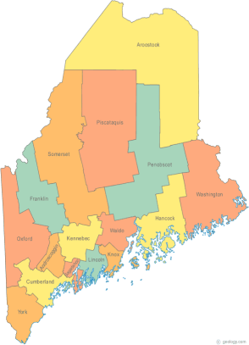 | Maine Homeless Policy Committee  Agenda  Friday, March 4, 2016 3:00PM  Community Housing of Maine  One City Center, 4th Floor  Portland, ME 04101  Call-in number 1-605-475-4350  Access Code: 810236#
-Agenda Items-

- Welcome/Introductions/Attendance | Group

- Items of Current Focus  Federal & State Legislation | Cullen

- Proactive Strategies | Group

- Next Meeting (confirm time and location)/Adjournment

