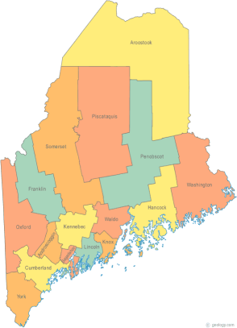 | Maine Continuum of Care (MCOC) Agenda  December 17, 2015 1:00 pm to 3:00 pm  Meeting at these locations via Tandberg Conferencing System.  - Turner Memorial Library, 39 2nd St., Presque Isle  (University locations are no longer available due to classes in these rooms)  - Farmington Public Library, 117 Academy Street, Farmington  - MaineHousing, 353 Water Street, Augusta  - Lewiston Public Library, 200 Lisbon Street, Lewiston  - Portland Public Library, 5 Monument Square, Portland  THE CALL-IN ONLY NUMBER FOR THIS MEETING IS 866-6401  If you are at a Tandberg Location, use the system audio, not the call in.
---Agenda Items---
- Member Introductions |  | All
- Review & Approval of minutes |  |  | Need to Vote
- Steering Committee Update |  | All | Need to Vote
- Resource Committee Update |  | Chairs
- Data Committee Update & Data Quality Presentation |  | Chairs
- Project Committee Update |  | Chairs
- Policy Committee Update |  | Chairs
- State and Federal Legislation |  | Cullen
- Long Term Stayers Update |  | All
- PIT Methodology |  | Resource Committee | Need to Vote
- Vets@Home TA Scope of Work |  | Phil Allen
- Final rule on defining Chronic Homelessness |  | All
- Big Thinking Topic |  | All
- Any Other Business |  | All | Need to Vote
- Next Meetings: January 21st, 1pm to 3pm

Please read all posted materials prior to attending the meetings in order to be prepared to participate in the discussion.
Materials will be posted at www.mainehomelessplanning.org
Contact stibbitts@mainehousing.org for more information.

