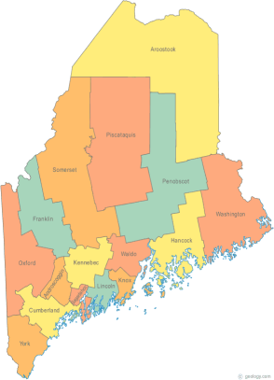 | Maine Continuum of Care (MCOC) Agenda  SPECIAL NOFA MEETING Nov. 12, 2015  1:00 pm to 3:00 pm  **NOT ALL OUR USUAL LOCATIONS ARE AVAILABLE FOR THESE MEETINGS, AND THE CALL IN NUMBER IS DIFFERENT!**  - Torrey Hall Rm 109 (or possibly 111) UMM Campus, Machias  - Farmington Public Library, 117 Academy Street, Farmington  - MaineHousing, 353 Water Street, Augusta  - Lewiston Public Library, 200 Lisbon Street, Lewiston  - Portland Public Library, 5 Monument Square, Portland  THE CALL-IN ONLY NUMBER FOR THIS MEETING IS 866-6408  If you are at a Tandberg Location, use the system audio, not the call in #.
---Agenda Items---
- Member Introductions |  | All
- Review & Approval of minutes |  |  | Need to Vote
- Review of final Scoring and Ranking results |  | All | Need to Vote
- Vote on the MCOC Governance |  | All | Need to Vote
- Finalize and vote to approve Section 3 |  | All | Need to Vote
- Vote to approve the entire Application, or Authorize the Steering Committee to finalize and submit the Application. |  | All | Need to Vote
- Any Other Business |  | All | Need to Vote
- Next Meetings: November 19th , 1pm to 3pm

Please read all posted materials prior to attending the meetings in order to be prepared to participate in the discussion.
Materials will be posted at www.mainehomelessplanning.org
Contact stibbitts@mainehousing.org for more information.

