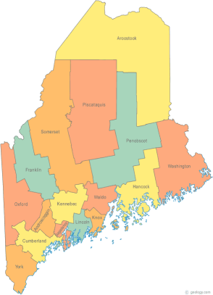 | MCOC Policy Committee  Agenda  Friday, March 20, 2015 3:00PM  Community Housing of Maine  309 Cumberland Ave., Suite 203  Portland, ME 04101  Call-in number 1-605-475-4350  Access Code: 810236# | All Committee Agendas and Minutes will be sent to MCOC Chairs by the 10th of each month for inclusion in materials sent to all members prior to each monthly MCOC meeting.
-Agenda Items-

- Welcome/Introductions/Attendance | Group

- State and Federal Legislation Updates and Action Items | Group

- Merging with the Statewide Homeless Council Policy Committee as a Joint Standing Committee | Group

- Next Meeting (confirm time and location)/Adjournment

