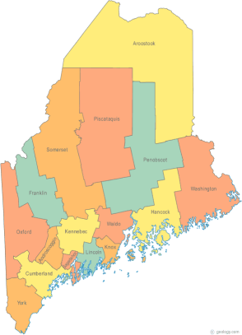 | MCOC Policy Committee  Minutes  Friday, January 16, 2015 3:00PM  Community Housing of Maine  309 Cumberland Ave., Suite 203  Portland, ME 04101  Call-in number 1-605-475-4350  Access Code: 810236# | All Committee Agendas and Minutes will be sent to MCOC Chairs by the 10th of each month for inclusion in materials sent to all members prior to each monthly MCOC meeting.
-Agenda Items-

- Welcome/Introductions/Attendance  Attendance: Vickey Rand, Cullen Ryan, Ginny Dill, Awa Conteh, Steve Ellis, and Jerry DeWitt.  Unable to attend: Chet Barnes, Donna Kelley, and Lucy Barnhart. | Group

- State and Federal Legislation Updates and Action Items  Please refer to the previously forwarded report. The highlights were reviewed. | Group

- Other Business | Group

- Next Meeting (confirm time and location)/Adjournment
- The next meeting is scheduled for: Friday, March 20th at 3:00 pm

