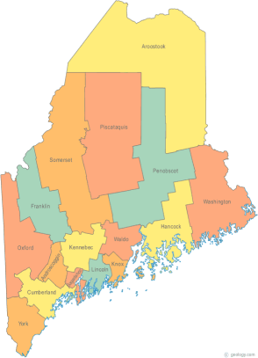 | Maine Continuum of Care (MCOC) Agenda  January 15, 2015 12:00 pm to 3:00 pm  Meeting at SEVEN locations via Tandberg Conferencing System.  - Turner Memorial Library, 39 2nd St., Presque Isle (pending confirmation)  - Torrey Hall Rm 109 (or possibly 111)UMM Campus, Machias (NEW)  - Bangor Public Library, 145 Harlow Street, Bangor (need alternate site)  - Farmington Public Library, 117Academy Street, Farmington  - MaineHousing, 353 Water Street, Augusta  - Lewiston Public Library, 200 Lisbon Street, Lewiston  - Portland Public Library, 5 Monument Square, Portland
---Agenda Items---

Please note that this month there will be a discussion on Coordinated Assessment, starting at 12:00, prior to the regular monthly meeting, which will begin at 1:00. All are encouraged to participate.

- Member Introductions |  | All
- Review & Approval of minutes |  | All | Need to Vote
- Steering Committee |  | Chairs
- Project Committee |  | Chairs
- Scoring Committee |  | Chairs
- Resource Committee |  | Chairs
- Data Committee |  | Chairs
- Policy Committee |  | Chairs
- Long Term Stayers Initiative |  | All
- Statewide Homeless Council |  | Cullen or Wes
- Coordinated Assessment Update
- Performance Measures Overview
- Reallocation Discussion
- PIT – Wednesday, January 28th, 2015
- Announcements & Updates
- Any Other Business
- Next Meeting
- February 19th, 1pm to 3pm
Please bring all e-mailed material to the meeting. Contact stibbitts@mainehousing.org for more information.

