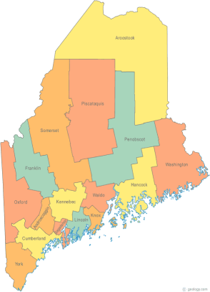 | Maine Continuum of Care (MCOC) Agenda  December 18, 2014 1:00 pm to 3:00 pm  Meeting at SEVEN locations via Tandberg Conferencing System.  - Turner Memorial Library, 39 2nd St., Presque Isle (pending confirmation)  - Washington Academy, 66 High Street, East Machias  - Bangor Public Library, 145 Harlow Street, Bangor  - Farmington Public Library, 117Academy Street, Farmington  - MaineHousing, 353 Water Street, Augusta  - Lewiston Public Library, 200 Lisbon Street, Lewiston  - Portland Public Library, 5 Monument Square, Portland  Conference Call option for those not able to attend via Tandberg:  Dial 1-866-316-1519. When prompted, enter code 9284295#
---Agenda Items---
- Member Introductions |  | All
- Review & Approval of minutes |  | All | Need to Vote
- Steering Committee |  | Chairs
- Project Committee |  | Chairs
- Scoring Committee |  | Chairs
- Resource Committee |  | Chairs
- Data Committee |  | Chairs
- Policy Committee |  | Chairs
- Long Term Stayers Initiative |  | All
- Coordinated Assessment Presentation |  | Melany Mondello  & Anne Gass
- NOFA Debrief
- PIT – Wednesday, January 28th, 2015
- Statewide Homeless Council |  | Cullen or Wes
- Announcements & Updates
- Any Other Business
- Next Meeting
- January 15th, 1pm to 3pm
Please bring all e-mailed material to the meeting. Contact stibbitts@mainehousing.org for more information.

