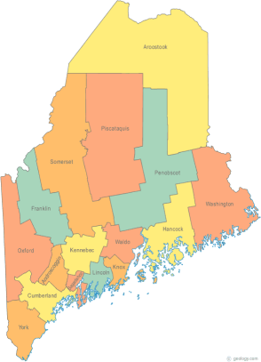 | Maine Continuum of Care (MCOC) Agenda  November 20, 2014 1:00 pm to 3:00 pm  Meeting at SEVEN locations via Tandberg Conferencing System.  - Turner Memorial Library, 39 2nd St., Presque Isle  - Washington Academy, 66 High Street, East Machias (pending confirmation)  - Bangor Public Library, 145 Harlow Street, Bangor  - Farmington Public Library, 117Academy Street, Farmington (pending confirmation)  - MaineHousing, 353 Water Street, Augusta  - Lewiston Public Library, 200 Lisbon Street, Lewiston  - Portland Public Library, 5 Monument Square, Portland
---Agenda Items---
- Member Introductions |  | All
- Review & Approval of minutes |  | All | Need to Vote
- Steering Committee |  | Chairs
- Project Committee |  | Chairs
- Scoring Committee |  | Chairs
- Resource Committee |  | Chairs
- Data Committee |  | Chairs
- Policy Committee |  | Chairs
- HMIS Governance Committee |  | Chairs
- AHAR
- HCV Applications – Homeless Referral System |  | MaineHousing
- PIT
- NOFA Debrief
- Statewide Homeless Council  -No meeting in November. Next is Dec. 9th. |  | Cullen or Wes
- Announcements & Updates
- Any Other Business
- Next Meeting
- December 18th, 1pm to 3pm
Please bring all e-mailed material to the meeting. Contact stibbitts@mainehousing.org for more information.

