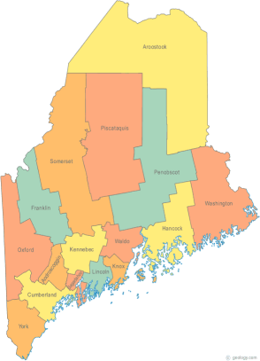 | Maine Continuum of Care (MCOC) Agenda  October 16, 2014 1:00 pm to 3:00 pm  Meeting at SIX locations via Tandberg Conferencing System.  - Turner Memorial Library, 39 2nd St., Presque Isle (pending confirmation)  - Washington Academy, 66 High Street, East Machias Maine  - Bangor Public Library, 145 Harlow Street, Bangor  - Farmington Public Library, 117Academy Street, Farmington (pending confirmation)  - MaineHousing, 353 Water Street, Augusta  - Lewiston Public Library, 200 Lisbon Street, Lewiston  - Portland Public Library, 5 Monument Square, Portland  To join by conference line, call 1-866-316-1519, passcode 9284295#.
---Agenda Items---
- Member Introductions |  | All
- Review & Approval of minutes |  | All | Need to Vote
- Steering Committee
- Project Committee
- Scoring Committee |  | Chairs
- Resource Committee |  | Chairs
- Data Committee |  | Chairs
- Policy Committee |  | Vickey
- Maine Consolidated Plan
- CoC Debriefing Summary/Scores
- Review NOFA Timeline
- PSH Chronic Homeless Prioritization
- Recommendations for Tier 1 & 2
- Nominations and Vote for Tri-Chair
- CoC Program Start Up Training update
- CSI/Maine Behavioral Health update
- Statewide Homeless Council  - No meeting in November. Next is Dec. 9th. |  | Cullen or Wes
- Announcements & Updates
- Any Other Business
- Next Meeting - November 20th, 1pm to 3pm
Please bring all e-mailed material to the meeting. Contact stibbitts@mainehousing.org for more information.

