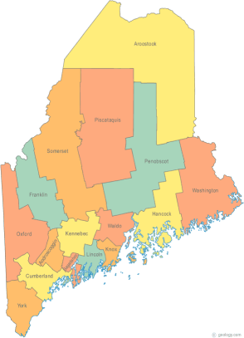 | MCOC Policy Committee  Minutes  Tuesday, September 16, 2014 4:00PM  Community Housing of Maine  309 Cumberland Ave., Suite 203  Portland, ME 04101  Call-in number 1-605-475-4350  Access Code: 810236# | All Committee Agendas and Minutes will be sent to MCOC Chairs by the 10th of each month for inclusion in materials sent to all members prior to each monthly MCOC meeting.
-Agenda Items-

- Welcome/Introductions/Attendance  Attendance: Cullen Ryan, Vickey Rand, Ginny Dill, Chet Barnes, and Awa Conteh. Unable to attend: Heather Rhoda and Donna Kelley | Group

- State and Federal Legislation Updates and Action Items  Please refer to the previously forwarded report. The highlights were reviewed. | Group

- Other Business  - There was discussion regarding the “Zero: 2016 campaign,” the follow-up to the 100K Homes campaign. The CoC tasked the Policy Committee with looking into the principles of the campaign and how Maine can adopt them without formally joining. The highlights of the Zero: 2016 campaign were reviewed. Next steps for the CoC:  - Establish take down targets – the number of Veterans experiencing homelessness and individuals experiencing chronic homelessness that need to obtain permanent housing to end Veteran and chronic homelessness in Maine;  - Break these targets down into easily attainable monthly housing goals; and  - Analyze the continuum’s gaps, including any lack of permanent housing or subsidies, which could prevent the CoC from achieving the take down targets.  - The group discussed the long term stayers initiative. | Group

- Next Meeting (confirm time and location)/Adjournment
- Unless otherwise decided meetings will occur on the third Tuesday of every other month at 4:00 PM.
- The next meeting is scheduled for Tuesday, November 18th at 4:00 PM.

