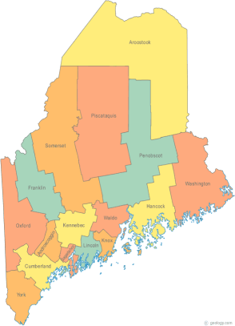 | MCOC Resource Committee  Minutes  May 20, 2014 – 2:30PM-4:00PM  Maine State Library  Video conference | All Com Agendas and Minutes will be sent to MCOC Chairs by the 10th of each month for inclusion in materials sent to all members prior to each monthly MCOC meeting.
-Agenda Items- | Assigned to… | Due Date

- Welcome/Introductions/Attendance  In attendance: Mike Mooney, Melody Fitch, Betty Palmer, Michael Tilton |  | N/A

- Approval of Agenda/Additions/Adjustment  Agenda reviewed |  | N/A

- Review/Approval of Minutes  April 2014 Minutes revised and approved: |  | N/A

- Updates on Action Items assigned at prior meeting:  - Phone calls to strengthen survey Results: In an effort to reach out to homeless partners, in April we agreed to call: Mike (Tedford Shelter and Common Ties); Betty (Bread of Life and Kennebec Behavioral Health) and Melody (Hope and Justice Project and Homeless Services of Aroostook). We did not make these calls.  - Training topics, esp. in area of employment/income: We discussed offering a brainstorming workshop in September for the Region II Homeless Council mtg, posing the question: What are your programs doing that works for people who are homeless?  - Training topic: We discussed asking a homeless provider to host the monthly Resource Committee meeting at their site, and we will facilitate a conversation with their staff and others they would like to invite, posing the question: What are you doing now that works for people experiencing homelessness and how can we help? Betty will contact Giff and Craig.  - Ideas to improve welcoming packet and orienting new members: Betty and Mike working on orientation packet | Mike  Betty  Betty and Mike | Info by June mtg?  Info by June mtg?

- New Business
N/A

- General Discussion/Information Items
N/A

- Next Meeting (confirm time and location)/Adjournment
Next Meeting: June 17, 2014
2:30-4:00pm at Maine State Library

Additional Instructions:

