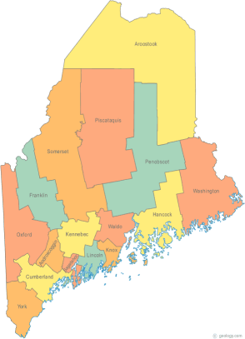 | MCOC Policy Committee  Agenda  Friday, May 30, 2014 10:00AM-11:00AM  Community Housing of Maine  309 Cumberland Ave., Suite 203  Portland, ME 04101  Call-in number 1-605-475-4350  Access Code: 810236# | All Committee Agendas and Minutes will be sent to MCOC Chairs by the 10th of each month for inclusion in materials sent to all members prior to each monthly MCOC meeting.
-Agenda Items-

- Welcome/Introductions/Attendance | Group

- Chair/Co-Chair Nominations | Group

- State and Federal Legislation Updates and Action Items | Group

- Other Business

- Next Meeting (confirm time and location)/Adjournment

