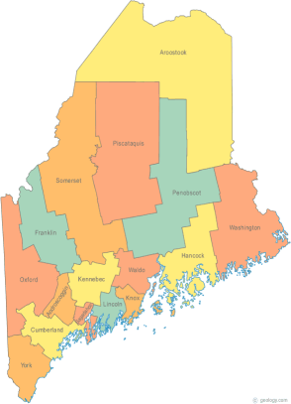 | Maine Continuum of Care (MCOC) Agenda  April 17, 2014 1:00 pm to 3:00 pm  Meeting at SIX locations via Tandberg Conferencing System.  - Turner Memorial Library, 39 2nd St., Presque Isle (via Tandberg Movi)  - NEW! Washington Academy, 66 High Street, East Machias  - Bangor Public Library, 145 Harlow Street, Bangor  - Farmington Public Library, 117Academy Street, Farmington  - Maine State Library, 230 State Street, Augusta  - Portland Public Library, 5 Monument Square, Portland
---Agenda Items---
- Member Introductions |  | All
- Review/Approval of minutes |  | All
- Announments/updates
- Tandberg Conference Sites  - Welcome Washington County!  - Additional locations? |  | All
- HUD Tier 1 Announcement |  | Chairs
- Ad Hoc Governance Committee
- Latest (Last?) DRAFT Review
- MCOC Work Plan Priorities
- Tasks
- Steering Committee |  | Chairs
- Project Committee
- Reallocation discussion

- Scoring Committee
- Resource Committee
- Orientation Information (and teleconferencing etiquette)

- Data Committee
- PIT Reports Posted
- PIT and HIC approval

- HMIS Advisory Committee

- Policy Committee |  | Cullen
- Statewide Homeless Council |  | Wes
- Any Other Business
- Next Meeting
- May 15, 2014 1pm to 3pm
Please bring all e-mailed material to the meeting. Contact stibbitts@mainehousing.org for more information.

