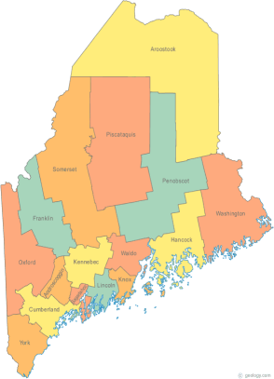 | Maine Continuum of Care (MCOC) Agenda  January 16, 2014 1:00 pm to 3:00 pm  MCOC will be meeting simultaneously at different  locations via the Tandberg Teleconferencing System.  - Turner Memorial Library, 39 2nd Street, Presque Isle (not available)  - Bangor Public Library, 145 Harlow Street, Bangor  - Farmington Public Library, 117Academy Street, Farmington  - Maine State Library, 230 State Street, Augusta  - Portland Public Library, 5 Monument Square, Portland (not available)  And by Conference Call at 1-866-316-1519, passcode 9284295#
---Agenda Items---
- Member Introductions |  | All
- Review/Approval of minutes |  | All
- Old Business: Updates on work in progress |  | All
- NOFA – Updates
- Progress to date
- New information
- What’s left to do

- Scoring and Ranking of Renewal Projects
-Project Committee Proposal
-where does the T1/T2 line fall
- results must be announced by tomorrow
- Joint HMIS Governance
- New DRAFT MCOC Governance
- New Fair Housing Policy
- Vote to Approve?
- Steering Committee |  | Chairs
- Project Committee |  | Wes, Tiffany, Donna & Chet
- Data Committee  - PIT and HIC updates |  | Ginny, Awa
- Resource Committee  -Year End Summary  - McKinney Vento Educational Assurances |  | Joe & Mike
- Policy Committee  - State and Federal Updates  - LD 1717  - McKinney Funding |  | Cullen
- Statewide Homeless Council |  | Wes & Cullen
- Other Business:
- Next SPECIAL EXTRA Meeting
-January 23, 2014 1pm to 3pm
Please bring all e-mailed material to the meeting. Contact stibbitts@mainehousing.org for more information.

