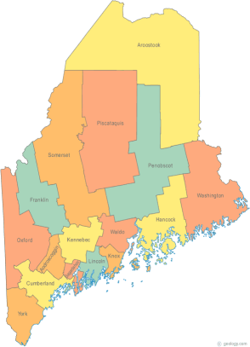
Maine Continuum of Care
Project Timeline

On Friday, November 22, 2013, HUD released the Notice of Funding Availability (NOFA) for the Continuum of Care Program Competition.

Mon. Dec. 2, 2013: Steering Committee Meeting with Anne
Gass, Consultant to review the NOFA
Application, its changes and plan to
complete Sections 3 and 4.

Mon. Dec. 9, 2013 Steering Committee Meeting and
Work session with Anne Gass to continue work and set the timeline for goals and objectives

Mon. Dec. 16th, 2013 Project Committee Meeting to review
scoring template in am and Steering
committee in the afternoon

Thu. Dec. 19th, 2013 Maine CoC meeting

Mon. Dec. 30th, 2013 Joint Project and Steering Committee
Meeting at 10:00am-3:00 pm

Fri. Jan. 3, 2014 E-SNAPS PROJECT APPLICATION
(former Exhibit 2) DEADLINE TO
COMPLETE

Mon. Jan. 6, 2014 Steering Committee Work Session

Mon. Jan. 13, 2014 Steering Committee Work Session

Thu. Jan. 16, 2014 Maine CoC Meeting to finalize and approve
the NOFA application.

Fri. Jan. 17, 2014 CoC Notification to Project Applicants

Thu. Jan 23, 2014 Maine CoC Meeting to finalize and approve
the NOFA application

Mon. Jan. 27, 2014 Steering Committee Work Session to
Complete any unfinished items

FEBRUARY 3, 2014 GRANT APPLICATION DUE TO HUD
(Monday)
*********************
FMI:
Paula Paladino, Manager of Homeless Initiatives: ppaladino@mainehousing.org OR
Anne Gass, Grant Consultant, agass@maine.rr.com

