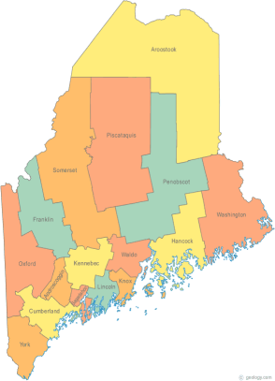 | Maine Continuum of Care (MCOC) Agenda  November 21, 2013 1:00 pm to 3:00 pm  MCOC will be meeting simultaneously at FIVE different  locations via the Tandberg Teleconferencing System.  - Turner Memorial Library, 39 2nd Street, Presque Isle  - Bangor Public Library, 145 Harlow Street, Bangor  - Farmington Public Library, 117Academy Street, Farmington  - Maine State Library, 230 State Street, Augusta  - Portland Public Library, 5 Monument Square, Portland
---Agenda Items---
- Member Introductions |  | All
- Review/Approval of minutes |  | All
- Old Business: Updates on work in progress |  | All
- New Business  - HUD TA Performance Measures-Update |  | Heather
- AHAR – Draft Update |  | Cindy
- HMIS Governance (Portland Legal looking at it too) |  | Cindy
- Steering Committee |  | Donna, Ginny, Heather
- Project Committee  - Review/Approve Renewal Scoring Template  - Monitoring results & follow-up  - Separate these two committees |  | Wes, Tiffany, Donna, Chet
- Data Committee |  | Awa, Ginny
- Resource Committee |  | Mike, Joe
- Policy Committee |  | Cullen
- Statewide Homeless Council |  | Regional Reps.
- Other Business:

- Next meeting
-December 19, 2013
Please bring all e-mailed material to the meeting. Contact stibbitts@mainehousing.org for more information.

