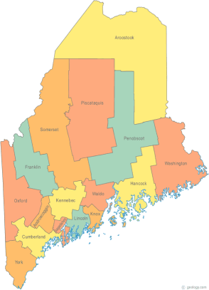 | Maine Continuum of Care (MCOC) Agenda  October 17, 2013 1:00 pm to 3:00 pm  MCOC will be meeting simultaneously at FIVE different  locations via the Tandberg Teleconferencing System.  - Turner Memorial Library, 39 2nd Street, Presque Isle  - Bangor Public Library, 145 Harlow Street, Bangor  - Farmington Public Library, 117Academy Street, Farmington  - Maine State Library, 230 State Street, Augusta  - Portland Public Library, 5 Monument Square, Portland
---Agenda Items---
- Member Introductions |  | All
- Review/Approval of minutes |  | All
- Old Business: Updates on work in progress

- New Business  - TRI-CHAIR Nominations (Sandra’s seat)  - HUD TA Performance Measures  - Planning Grant –Committee Nominees for:  - Coordinated Assessment (2 people)  - Project Monitoring & Evaluation (2 people)  - Collaborative Applicant NOFA Goals Meetings  - PATH Information |  | All  Bob & Cindy  Bob & Cindy  Cindy & Anne  Sheldon Wheeler & Don Harden
- Steering Committee

- Project Committee
- Renewal Scoring Template
- Monitoring results & follow-up

- Data Committee
- PIT/HIC prep

- Resource Committee
- Trainings and workshops

- Policy Committee

- Statewide Homeless Council
- Shelter Funding Ad Hoc Committee
- Long Term Stayers Initiatives
- Discharge Planning

- Other Business:
- Affordable Housing Conference October 30th

- Next meeting
-November 21, 2013
Please bring all e-mailed material to the meeting. Contact stibbitts@mainehousing.org for more information.

